BATH COUNTY SCHOOL DISTRICT

REPORT OF AUDIT

Year Ended June 30, 2003

BATH COUNTY SCHOOL DISTRICT

TABLE OF CONTENTS

Year Ended June 30, 2003

Pages

Independent Auditor’s Report 1 – 2

Management’s Discussion and Analysis 3 - 7

Basic Financial Statements:

Government-wide Financial Statements

Statement of Net Assets 8

Statement of Activities 9 - 10

Fund Financial Statements

Balance Sheet – Governmental Funds 11

Reconciliation of the Balance Sheet – Governmental
Funds to the Statement of Net Assets 12

Statement of Revenues, Expenditures and
Changes in Fund Balances - Governmental Funds 13

Reconciliation of the Statement of Revenues,
Expenditures and Changes in Fund Balances of
Governmental Funds to the Statement of Activities 14

Statement of Revenues, Expenditures and
Changes in Fund Balance – Budget and
Actual – General Fund 15

Statement of Net Assets – Proprietary Funds 16

Statement of Revenues, Expenses and
Changes in Net Assets – Proprietary Funds 17

Statement of Cash Flows – Proprietary Funds 18

Statement of Fiduciary Net Assets – Activity Funds 19

Notes to the Basic Financial Statements 20 - 39

BATH COUNTY SCHOOL DISTRICT

TABLE OF CONTENTS

Year Ended June 30, 2003

Pages

Supplementary Information:

Combining Statements – Nonmajor Funds:

Combining Balance Sheet – Nonmajor
Governmental Funds 40

Combining Statement of Revenues,
Expenditures and Changes in Fund Balances –
Nonmajor Governmental Funds 41

Statement of Revenues, Expenditures and
Changes in Fund Balance – Bath County High
School Activity Fund 42

Combining Statement of Revenues, Expenditures and
Changes in Fund Balance – Middle and Elementary
School Activity Funds 43

Schedule of Individual Debt Service Requirements 44 - 46

Schedule of Expenditures of Federal Awards 47 - 48

Report on Compliance and on Internal Control
Over Financial Reporting Based on an Audit
of Financial Statements Performed in Accordance
with Government Auditing Standards 49 - 50

Report on Compliance with Requirements Applicable
to Each Major Program and Internal Control Over
Compliance in Accordance with OMB Circular A-133 51 - 52

Summary Schedule of Prior Audit Findings 53

Schedule of Findings and Questioned Costs 54

Management Letter 55 - 59

INDEPENDENT AUDITOR’S REPORT

State Committee For School District Audits
Members of Bath County Board of Education
Owingsville, Kentucky

We have audited the accompanying basic financial statements of Bath County School District, as of and for the year ended June 30, 2003, which collectively comprise the District’s basic financial statements as listed in the table of contents. These financial statements are the responsibility of Bath County School District’s management. Our responsibility is to express an opinion on these financial statements based on our audit.

We conducted our audit in accordance with auditing standards generally accepted in the United States of America and the standards applicable to financial audits contained in Government Auditing Standards, issued by the Comptroller General of the United States. Those standards require that we plan and perform the audit to obtain reasonable assurance about whether the financial statements are free of material misstatement. An audit includes examining, on a test basis, evidence supporting the amounts and disclosures in the financial statements. An audit also includes assessing the accounting principles used and significant estimates made by management, as well as evaluating the overall financial statement presentation. We believe that our audit provides a reasonable basis for our opinions.

In our opinion, the financial statements referred to above present fairly, in all material respects, the financial position of the Bath County School District as of June 30, 2003, and the respective changes in financial position and cash flows, where applicable, thereof for the year then ended in conformity with accounting principles generally accepted in the United States of America.

As described in Note B, the District has implemented a new financial reporting model, as required by the provisions of GASB Statement No. 34, Basic Financial Statements – and Management’s Discussion and Analysis – for State and Local Governments, as of June 30, 2003.

The management’s discussion and analysis is not a required part of the basic financial statements but is supplementary information required by accounting principles generally accepted in the United States of America. We have applied certain limited procedures, which consisted principally of inquires of management regarding the methods of measurement and presentation of the supplementary information. However, we did not audit the information and express no opinion on it.

2.

In accordance with Government Auditing Standards, we have also issued our report dated August 14, 2003, on our consideration of Bath County School District’s internal control over financial reporting and our tests of its compliance with certain provisions of laws, regulations, contracts, and grants. That report is an integral part of an audit performed in accordance with Government Auditing Standards and should be read in conjunction with this report in considering the results of our audit.

Our audit was conducted for the purpose of forming an opinion on the financial statements that collectively comprise the Bath County School District’s basic financial statements. The accompanying schedule of expenditures of federal awards is presented for purposes of additional analysis as required by the U.S. Office of Management and Budget Circular A-133, Audits of States, Local Governments and Non-Profit Organizations, and is not a required part of the general purpose financial statements of Bath County School District. The combining and individual nonmajor fund financial statements, and other supplemental information are presented for purposes of additional analysis and are not a required part of the basic financial statements. The schedule of expenditures of federal awards, the combining and individual nonmajor fund financial statements, and other supplemental information have been subjected to the auditing procedures applied in the audit of the basic financial statements and, in our opinion, are fairly stated in all material respects in relation to the basic financial statements taken as a whole.

Chris Gooch
Certified Public Accountant

Hazard, Kentucky

August 14, 2003

3.

BATH COUNTY SCHOOL DISTRICT

OWINGSVILLE, KENTUCKY

MANAGEMENT’S DISCUSSION AND ANALYSIS

Year Ended June 30, 2003

As management of the Bath County School District, we offer readers of the District’s financial statements this narrative overview and analysis of the financial activities of the District for the fiscal year ended June 30, 2003. This information should be considered in conjunction with the accompanying financial statements and disclosure following this section.

FINANICAL HIGHLIGHTS

- The beginning cash balance, including activity funds, for the District was $2,167,384. The ending cash balance, including activity funds, for the District was $2,040,866.

- Ongoing and completed construction projects with costs totaling $182,587 for the year ended included the BCHS Vo-ag building project and the Bethel HVAC project.

- The District acquired four new school busses through a KISTA bond issue. The total acquisition cost for the four vehicles was $229,608.

- The District issued $955,000 in school building refunding revenue bonds to defease the Series of 1992 bonds. The Kentucky School Facilities Commission participated in approximately 61% of the debt service. The savings to the District was $48,253.

- Interest revenue totaled $41,137 for the year ended and for the prior year the total interest revenue was $106,103.

- The District’s total long-term debt decreased by $246,086.

- Total general fund revenue was $8,337,817 consisting primarily of state program (SEEK), property, utilities and motor vehicle taxes. Excluding general fund transfers, there were $8,389,926 in general fund expenditures.

OVERVIEW OF FINANCIAL STATEMENTS

The discussion and analysis is intended to serve as an introduction to the District’s basic financial statements. The District’s basic financial statements comprise three components: 1) government-wide financial statements, 2) fund financial statements, and 3) notes to the financial statements. This report also contains other supplementary information in addition to the basic financial statements.
4.

BATH COUNTY SCHOOL DISTRICT

OWINGSVILLE, KENTUCKY

MANAGEMENT’S DISCUSSION AND ANALYSIS (continued)

Year Ended June 30, 2003

Government-wide financial statements

The government-wide financial statements are designed to provide readers with a broad overview of the District’s finances, in a manner similar to a private-sector business.

The statement of net assets presents information on all of the District’s assets and liabilities, with the difference between the two reported as net assets. Over time, increases or decreases in net assets may serve as a useful indicator of whether the financial position of the district is improving or deteriorating.

The statement of activities presents information showing how the District’s net assets changed during the most recent fiscal year. All changes in net assets are reported as soon as the underlying event giving rise to the change occurs, regardless of the timing of related cash flows. Thus, revenues and expenses are reported in this statement for some items that will only result in cash flows in future fiscal periods.

The government-wide financial statements outline functions of the District that are principally supported by property taxes and intergovernmental revenues (governmental activities). The governmental activities of the District include instruction, support services, operation and maintenance of plant, student transportation and operation of non-instructional services. Fixed assets and related debt is also supported by taxes and intergovernmental revenues.

Fund financial statements

A fund is a grouping of related accounts that is used to maintain control over resources that have been segregated for specific activities or objectives. This is a state mandated uniform system and chart of accounts for all Kentucky public school districts utilizing the MUNIS administrative software. The District uses fund accounting to ensure and demonstrate compliance with finance-related legal requirements. All of the funds of the District can be divided into three categories: governmental, proprietary and fiduciary funds. Fiduciary funds include activity funds. Proprietary funds include the school food service, daycare and preschool funds. All other activities are reported under governmental funds.

Notes to the Financial Statements

The notes provide additional information that is essential to a full understanding of the data provided in the government-wide and fund financial statements.

5.

BATH COUNTY SCHOOL DISTRICT

OWINGSVILLE, KENTUCKY

MANAGEMENT’S DISCUSSION AND ANALYSIS (continued)

Year Ended June 30, 2003

GOVERNMENT-WIDE FINANCIAL ANALYSIS

Net assets may serve over time as a useful indicator of a government’s financial position. As of June 30, 2003, assets exceeded liabilities by 1,864,579.

The greatest portion of the District’s net assets reflects its investment in capital assets (e.g., land and improvements, buildings and improvements, vehicles, furniture and equipment and ongoing construction projects, where applicable), less any related debt used to acquire those assets that is still outstanding. The District uses these capital assets to provide services to its students; consequently, these assets are not available for future spending. Although the District’s investment in its capital assets is reported net of related debt, it should be noted that the resources needed to repay this debt must be provided from other sources, since the capital assets themselves cannot be used to liquidate these liabilities.

The District’s financial position is the product of several financial transactions including the net results of activities, the acquisition and payment of debt, the acquisition and disposal of capital assets, and the depreciation of capital assets.

Net assets for the year ended June 30, 2003

The current year’s financial statements are dramatically different from past years as a result of implementing GASB 34. Attempting to compare this year’s data with last year would be misleading to the reader; however, the district looks forward to offering comparative data in the future.
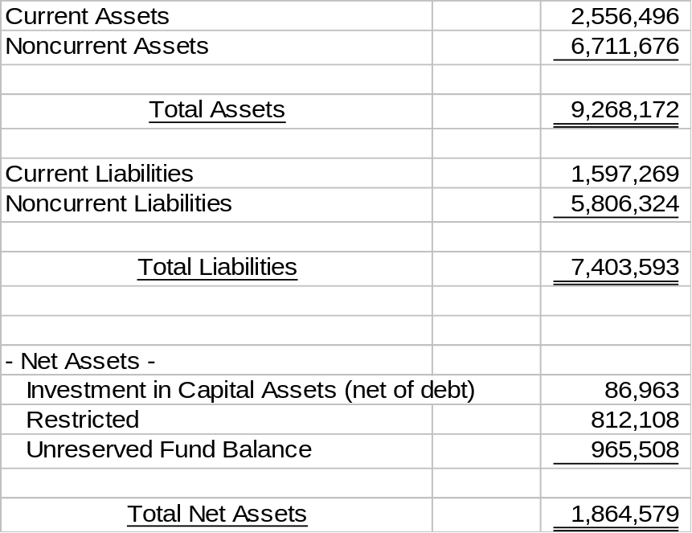
6.

BATH COUNTY SCHOOL DISTRICT

OWINGSVILLE, KENTUCKY

MANAGEMENT’S DISCUSSION AND ANALYSIS (continued)

Year Ended June 30, 2003

The following are significant current year transactions that impact the Statement of Net Assets:

- The District implemented GASB 34 and recorded fixed assets and debt for the first time.

Comments on budget comparisons

- The District’s total general fund revenues for the fiscal year ended June 30, 2003, net of interfund transfers, were $9,898,616.

- General fund budget compared to actual revenue reflects line item variances. The actual ending balance is 18% greater than budget.

- The total cost of all programs and services was $9,897,821, net of debt service.

- General fund budget expenditures to actual varied significantly in the following: Addition of on behalf state payments for Teacher’s retirement, life insurance, administration fees, health insurance and vocational education in the government wide statement of activities.

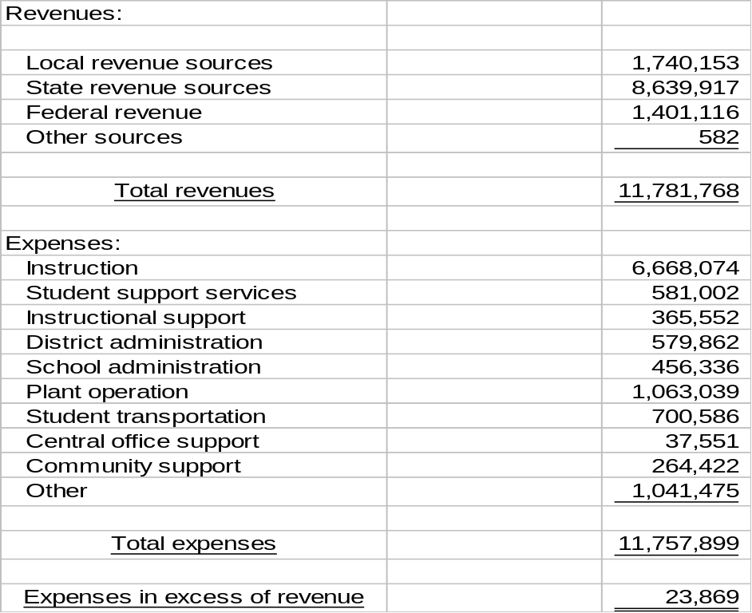The following table presents a summary of governmental funds revenue and expense for the fiscal year ended June 30, 2003:
7.

BATH COUNTY SCHOOL DISTRICT

OWINGSVILLE, KENTUCKY

MANAGEMENT’S DISCUSSION AND ANALYSIS (continued)

Year Ended June 30, 2003

BUDGETARY IMPLICATIONS

In Kentucky the public school fiscal year is July 1-June 30; other programs, i.e. some federal operate on a different fiscal calendar, but are reflected in the district overall budget. By law the budget must have a minimum 2% contingency. The district adopted a budget with $312,961 in contingency (3.37%). The beginning cash balance at the beginning of the fiscal year was $2,167,384.

Questions regarding this report should be directed to the Superintendent or the Finance Officer at (606) 674-6314.

8.

BATH COUNTY SCHOOL DISTRICT

STATEMENT OF NET ASSETS

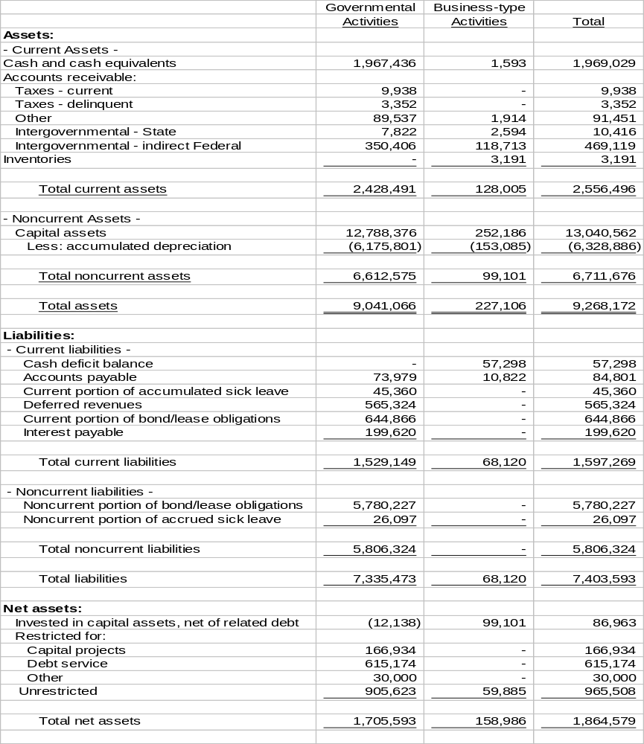At June 30, 2003

See notes to financial statements.
9.

BATH COUNTY SCHOOL DISTRICT

STATEMENT OF ACTIVITIES

Year Ended June 30, 2003
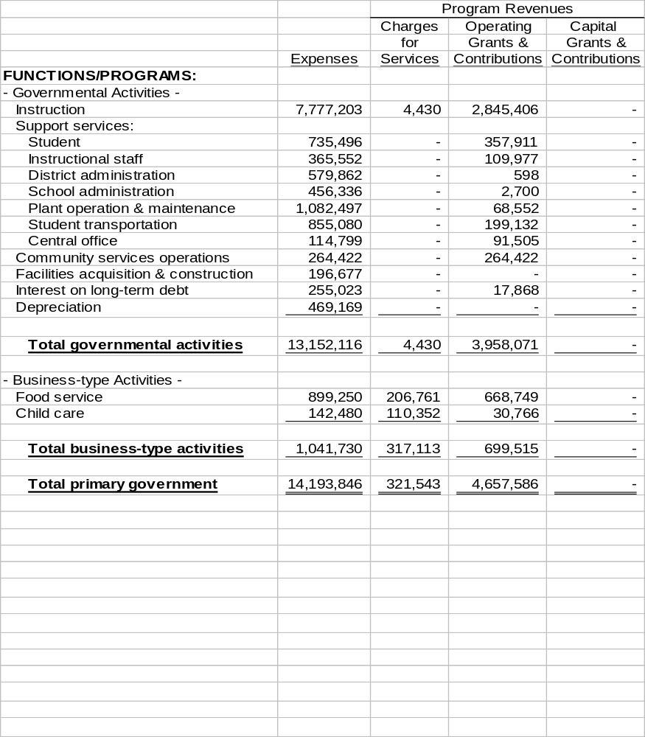

See notes to financial statements.
10.

BATH COUNTY SCHOOL DISTRICT

STATEMENT OF ACTIVITIES (continued)

Year Ended June 30, 2003

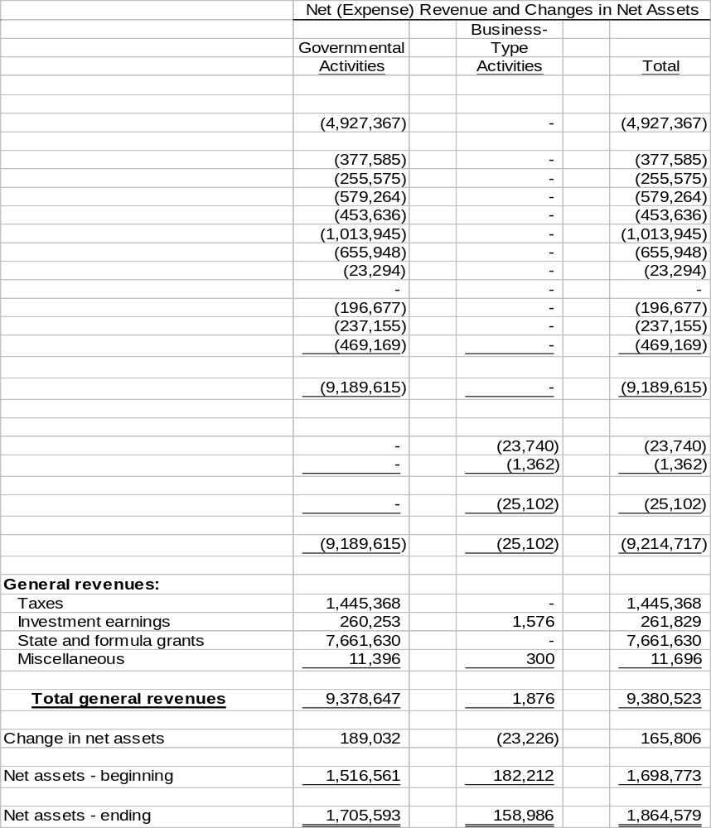

See notes to financial statements.
11.

BATH COUNTY SCHOOL DISTRICT

BALANCE SHEET – GOVERNMENTAL FUNDS

At June 30, 2003
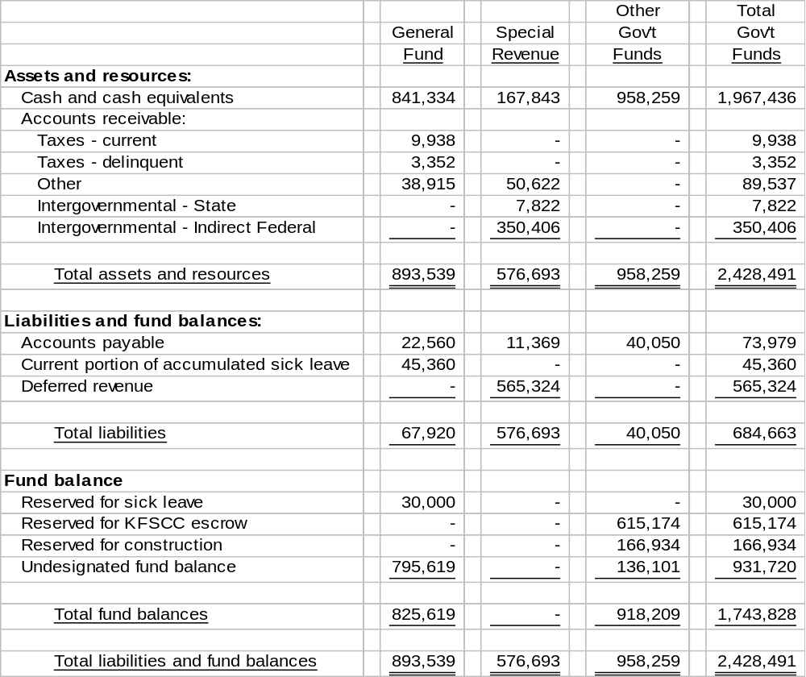

See notes to financial statements.
12.

BATH COUNTY SCHOOL DISTRICT

RECONCILIATION OF THE BALANCE SHEET –

GOVERNMENTAL FUNDS TO THE STATEMENT OF NET ASSETS

At June 30, 2003

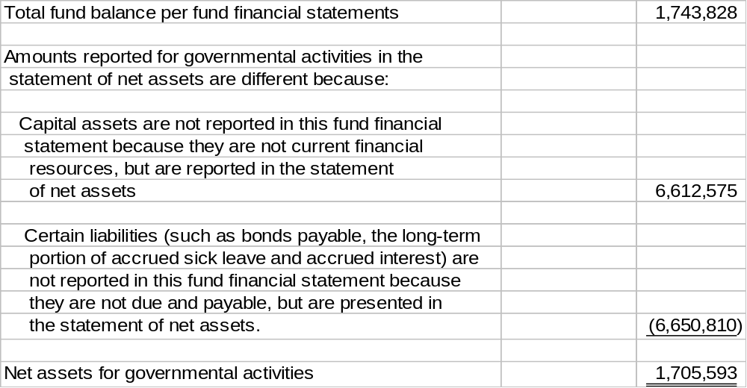

See notes to financial statements.
13.

BATH COUNTY SCHOOL DISTRICT

STATEMENT OF REVENUES, EXPENDITURES AND

CHANGES IN FUND BALANCE – GOVERNMENTAL FUNDS

Year Ended June 30, 2003
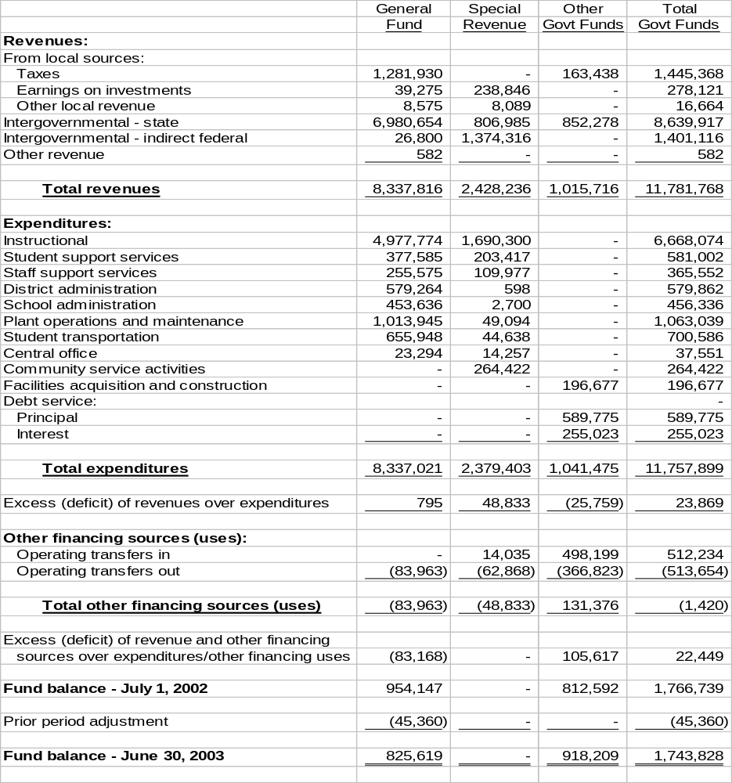

See notes to financial statements.
14.

BATH COUNTY SCHOOL DISTRICT

RECONCILIATION OF THE STATEMENT OF REVENUES,

EXPENDITURES AND CHANGES IN FUND BALANCES OF

GOVERNMENTAL FUNDS TO THE STATEMENT OF ACTIVITES

Year Ended June 30, 2003
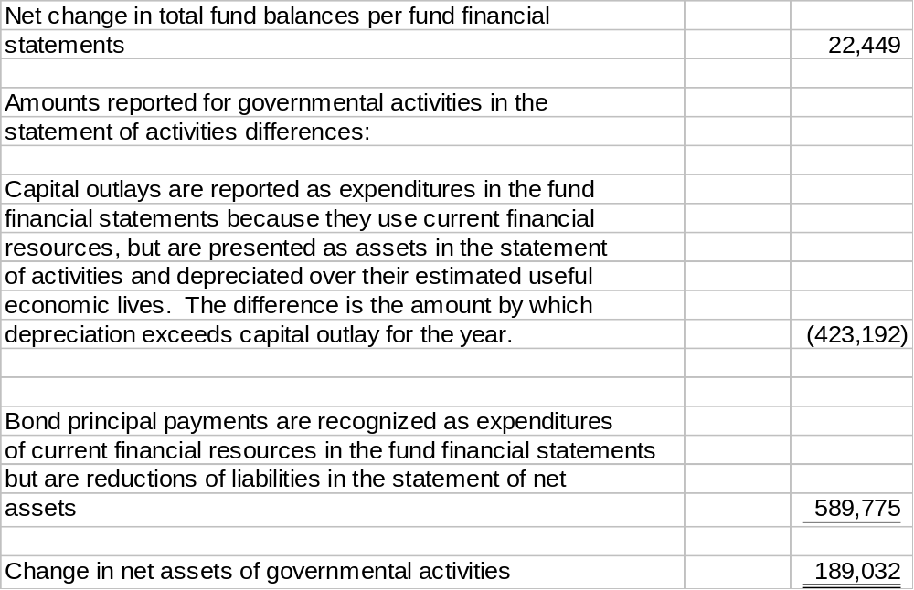

See notes to financial statements.
15.

BATH COUNTY SCHOOL DISTRICT

STATEMENT OF REVENUES, EXPENDITURES, AND CHANGES

IN FUND BALANCE – BUDGET AND ACTUAL – GENERAL FUND

Year Ended June 30, 2003
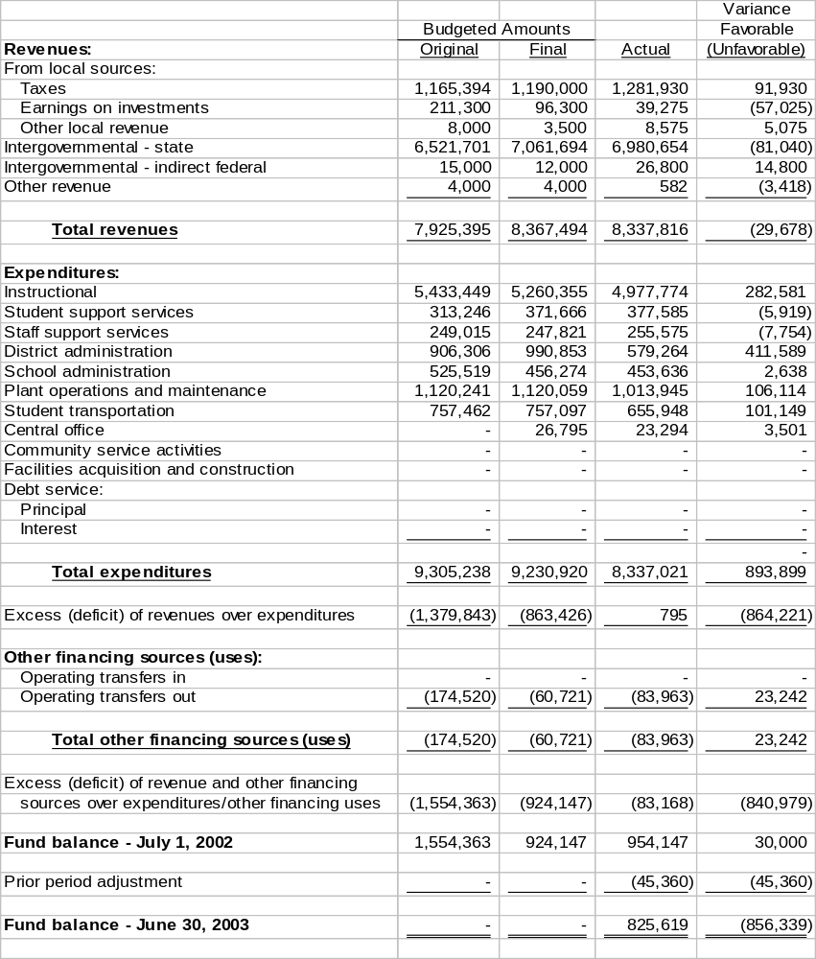

See notes to finanical statements.
16.

BATH COUNTY SCHOOL DISTRICT

STATEMENT OF NET ASSETS – PROPRIETARY FUND

At June 30, 2003
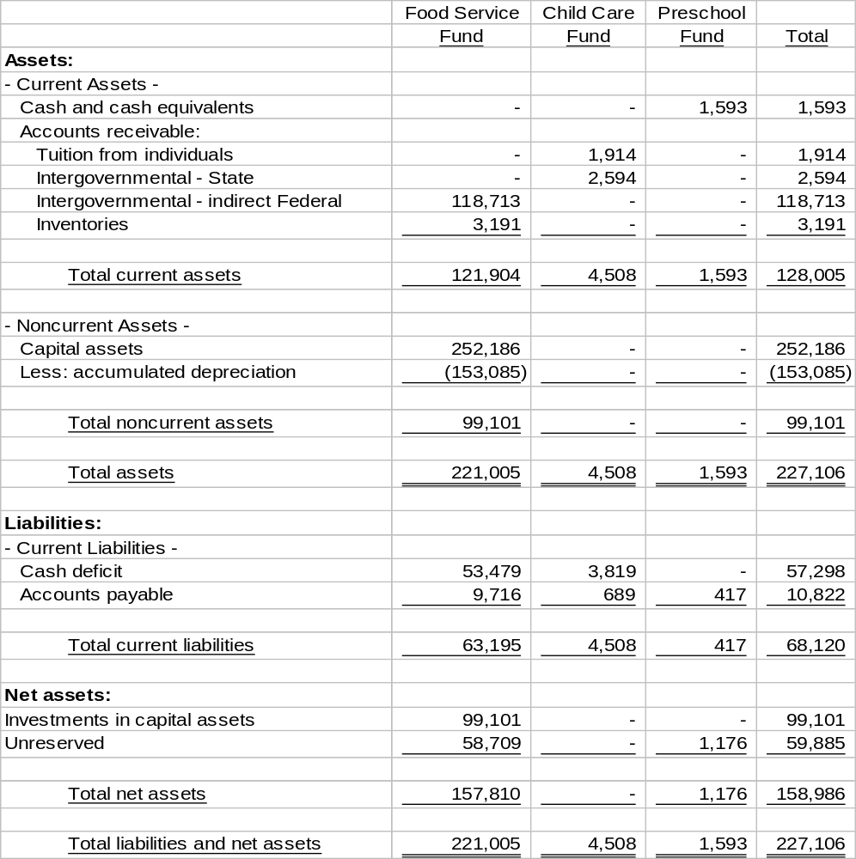

See notes to financial statements.
17.

BATH COUNTY SCHOOL DISTRICT

STATEMENT OF REVENUES, EXPENSES AND

CHANGES IN NET ASSETS – PROPEITARY FUNDS

Year Ended June 30, 2003

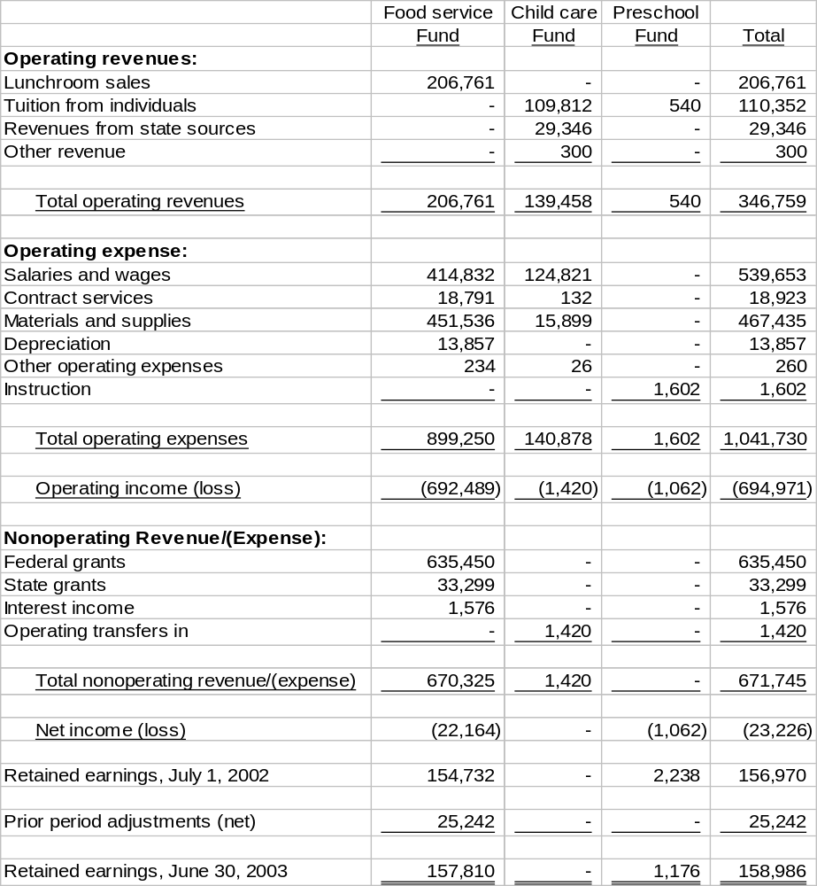

See notes to financial statements.
18.

BATH COUNTY SCHOOL DISTRICT

STATEMENT OF CASH FLOWS – PROPEITARY FUNDS

Year Ended June 30, 2003
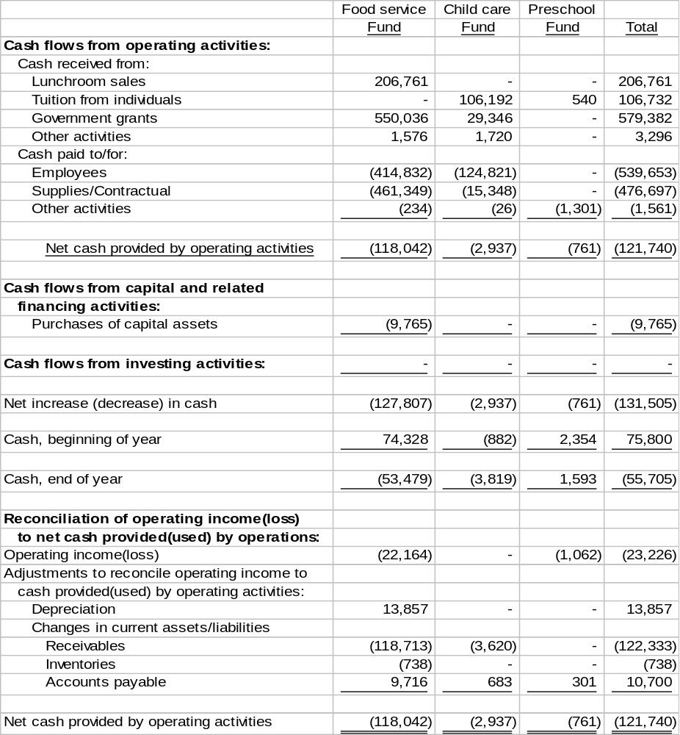

See notes to financial statements.
19.

BATH COUNTY SCHOOL DISTRICT

STATEMENT OF FIDUCIARY NET ASSETS – ACTIVITY FUNDS

At June 30, 2003

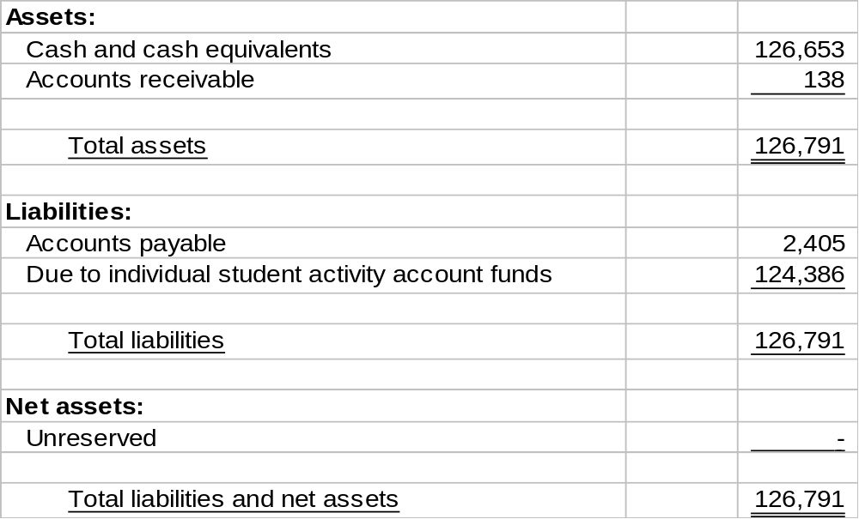

See notes to financial statements.
20.
BATH COUNTY SCHOOL DISTRICT

NOTES TO BASIC FINANCIAL STATEMENTS

June 30, 2003

NOTE A – REPORTING ENTITY AND SUMMARY OF SIGNIFICANT ACCOUNTING POLICIES

The Bath County Board of Education (Board), a five member group, is the level of government which has oversight responsibilities over all activities related to public elementary and secondary school education within the jurisdiction of Bath County School District (District). The Board receives funding from local, state and federal government sources and must comply with the commitment requirements of these funding sources entities. However, the Board is not included in any other governmental “reporting entity” as defined in Section 2100, Codification of Governmental Accounting and Financial Reporting Standards as Board members are elected by the public and have decision making authority, the power to designate management, the responsibility to develop policies which may influence, operations and primary accountability for fiscal matters.

The Board, for financial purposes, includes all of the funds and account groups relevant to the operation of the Bath County Board of Education. The financial statements presented herein do not include funds of groups and organizations, which although associated with the school system, have not originated within the Board itself such as Band Boosters, Parent-Teacher Associations, etc.

The financial statements of the Board include those of separately administered organizations that are controlled by or dependent on the Board. Control or dependence is determined on the basis of budget adoption, funding and appointment or the respective governing board.

Based on the foregoing criteria, the financial statements of the following organization are included in the accompanying financial statements:

Bath County School District Finance Corporation – On November 29, 1988, the Bath County, Kentucky, Board of Education resolved to authorize the establishment of the Bath County School District Finance Corporation (a non-profit, non-stock, public and charitable corporation organized under the School Bond Act and KRS 273 and KRS Section 58.180) as an agency of the Board for financing the costs of school building facilities. The Board Members of the Bath County Board of Education also comprise the Corporations’ Board of Directors.

The financial statements of the following entity are not included in the accompanying financial statements:

C. C. Chenault Memorial Trust

The Trust was created to establish agricultural programs for the District. The District receives a quarterly payment from the trust for its agricultural programs. The Trust maintains separate accounting records and is not governed nor managed by the District.

21.
BATH COUNTY SCHOOL DISTRICT

NOTES TO BASIC FINANCIAL STATEMENTS (CONTINUED)

June 30, 2003

NOTE A – REPORTING ENTITY AND SUMMARY OF SIGNIFICANT ACCOUNTING POLICIES (continued)

Basis of Presentation

Government-wide Financial Statements – The statement of net assets and the statement of activities display information about the District as a whole. These statements include the financial activities of the primary government, except for fiduciary funds. The statements distinguish between those activities of the District that are governmental and those that are considered business-type activities.

The government-wide statements are prepared using the economic resources measurement focus. This is the same approach used in the preparation of the proprietary fund financial statements but differs from the manner in which governmental fund financial statements are prepared. Governmental fund financial statements therefore include reconciliation with brief explanations to better identify the relationship between the government-wide statements and the statements for governmental funds.

The government-wide statement of activities presents a comparison between direct expenses and program revenues for each segment of the business-type activities of the District and for each function or program of the District’s governmental activities. Direct expenses are those that are specifically associated with a service, program or department and are therefore clearly identifiable to a particular function. Program revenues include charges paid by the recipient of the goods or services offered by the program and grants and contributions that are restricted to meeting the operational or capital requirements of a particular program. Revenues that are not classified as program revenues are presented as general revenues of the District, with certain limited exceptions. The comparison of direct expenses with program revenues identifies the extent to which each business segment or governmental function is self-financing or draws from the general revenues of the District.

Fund Financial Statements – Fund financial statements report detailed information about the District. The focus of governmental and enterprise fund financial statements is on major funds rather than reporting funds by type. Each major fund is presented in a separate column. Nonmajor funds are aggregated and presented in a single column. Fiduciary funds are reported by fund type.

The accounting and reporting treatment applied to a fund is determined by its measurement focus. All governmental fund types are accounted for using a flow of current financial resources measurement focus. The financial statements for governmental funds are a balance sheet, which generally includes only current assets and current liabilities, and a statement of revenues, expenditures and changes in fund balances, which reports on the changes in net total assets. Proprietary funds and fiduciary funds are reported using the economic resources measurement focus. The statement of cash flows provides information about how the District finances and meets the cash flow needs of its proprietary activities.
22.
BATH COUNTY SCHOOL DISTRICT

NOTES TO BASIC FINANCIAL STATEMENTS (CONTINUED)

June 30, 2003

NOTE A – REPORTING ENTITY AND SUMMARY OF SIGNIFICANT ACCOUNTING POLICIES (continued)

The District has the following funds:

- Governmental Fund Types

  - The General Fund is the primary operating fund of the District. It accounts for financial resources used for general types of operations. This is a budgeted fund, and any fund balances are considered as resources available for use. This is a major fund of the District.

  - The Special Revenue Grant Funds account for proceeds of specific revenue sources (other than expendable trusts or major capital projects) that are legally restricted to disbursements for specified purposes. It includes federal financial programs where unused balances are returned to the grantor at the close of specified project periods as well as the state grant programs. Project accounting is employed to maintain integrity for the various sources of funds. The separate projects of federally-funded grant programs are identified in the Schedule of Expenditures of Federal Awards included in this report. This is a major fund of the District.

  - Capital Project Funds are used to account for financial resources to be used for the acquisition or construction of major capital facilities and equipment (other than those financed by Proprietary Funds).

    - The Support Education Excellence in Kentucky (SEEK) Capital Outlay Fund receives those funds designated by the state as Capital Outlay Funds and is restricted for use in financing projects identified in the District’s facility plan.

    - The Facility Support Program of Kentucky Fund accounts for funds generated by the building tax levy required to participate in the School Facilities Construction Commission’s construction funding and state matching funds, where applicable. Funds may be used for projects identified in the District’s facility plan.

    - The Construction Fund accounts for proceeds from sales of bonds and other revenues to be used for authorized construction.

(D) The Debt Service Fund is used to account for the accumulation of resources for, and the payment of, general long-term debt principal and interest and related cost; and, for the payment of interest on general obligation notes payable, as required by Kentucky Law.
23.
BATH COUNTY SCHOOL DISTRICT

NOTES TO BASIC FINANCIAL STATEMENTS (CONTINUED)

June 30, 2003

NOTE A – REPORTING ENTITY AND SUMMARY OF SIGNIFICANT ACCOUNTING POLICIES (continued)

- Proprietary Funds (Enterprise Funds)

The School Food Service Fund is used to account for school food service activities, including the National School Lunch Program, which is conducted in cooperation with the U.S. Department of Agriculture (USDA). No amounts have been recorded for in-kind contribution of commodities from the USDA. The School Food Service Fund is a major fund.

The Childcare fund and Preschool fund accounts for revenues and expenditures related to daycare services and preschool activities.

- Fiduciary Fund Types (includes agency and trust funds)

The Activity Fund accounts for activities of student groups and other types of activities requiring clearing accounts. These funds are accounted for in accordance with Uniform Program of Accounting for School Activity Funds.

Basis of Accounting

Basis of accounting determines when transactions are recorded in the financial records and reported on the financial statements. Government-wide financial statements are prepared using the accrual basis of accounting. Governmental funds use the modified accrual basis of accounting. Proprietary and fiduciary funds also use the accrual basis of accounting.

Revenues – Exchange and Non-exchange Transactions – Revenues resulting from exchange transactions, in which each party receives essentially equal value, is recorded on the accrual basis when the exchange takes place. On a modified accrual basis, revenues are recorded in the fiscal year in which the resources are measurable and available. Available means that the resources will be collected within the current fiscal year or are expected to be collected soon enough thereafter to be used to pay liabilities of the current fiscal year. For the District, available means expected to be received within sixty days of the fiscal year-end.

Nonexchange transactions, in which the District receives value without directly giving equal value in return, include property taxes, grants, entitlements and donations. On an accrual basis, revenue from property taxes is recognized in the fiscal year for which the taxes are levied. Revenue from grants, entitlements and donations is recognized in the fiscal year in which all eligibility requirements have been satisfied. Eligibility requirements include timing requirements, which specify the year when the resource are required to be used or the fiscal year when use is first permitted, matching requirements,
24.
BATH COUNTY SCHOOL DISTRICT

NOTES TO BASIC FINANCIAL STATEMENTS (CONTINUED)

June 30, 2003

NOTE A – REPORTING ENTITY AND SUMMARY OF SIGNIFICANT ACCOUNTING POLICIES (continued)

Basis of Accounting (continued)

in which the District must provide local resources to be used for a specified purpose, and expenditure requirements, in which the resources are provided to the District on a reimbursement basis. On a modified accrual basis, revenues from nonexchange transactions must also be available before it can be recognized.

Deferred Revenue – Deferred revenue arises when assets are recognized before revenue recognition criteria have been satisfied.

Grants and entitlements received before the eligibility requirements are met are recorded as deferred revenue.

Expenses/Expenditures – On the accrual basis of accounting, expenses are recognized at the time they are incurred. The fair value of donated commodities used during the year is reported in the statement of revenues, expenses, and change is net assets as an expense with a like amount reported as donated commodities revenue. Unused donated commodities are reported as deferred revenues.

The measurement focus of governmental fund accounting is on decreases in net financial resources (expenditures) rather than expenses. Expenditures are generally recognized in the accounting period in which the related fund liability is incurred, if measurable. Allocations of cost, such as depreciation, are not recognized in governmental funds.

Property Taxes

Property Tax Revenues – Property taxes are levied each September on the assessed value listed as of the prior January 1, for all real and personal property in the county. The billings are considered due upon receipt by the taxpayer; however, the actual date is based on a period ending 30 days after the tax bill mailing. Property taxes collected are recorded as revenues in the fiscal year for which they were levied. All taxes collected are initially deposited into the General Fund and then transferred to the appropriate fund.

The property tax rates assessed for the year ended June 30, 2003, to finance the General Fund operations were $.332 per $100 valuation for real property, $.358 per $100 valuation for business personal property and $.380 per $100 valuation for motor vehicles.

The District levies a utility gross receipts license tax in the amount of 3% of the gross receipts derived from the furnishings, within the county, of telephonic and telegraphic communications services, cablevision services, electric power, water, and natural, artificial and mixed gas.
25.
BATH COUNTY SCHOOL DISTRICT

NOTES TO BASIC FINANCIAL STATEMENTS (CONTINUED)

June 30, 2003

NOTE A – REPORTING ENTITY AND SUMMARY OF SIGNIFICANT ACCOUNTING POLICIES (continued)

Capital Assets

General capital assets are those assets not specifically related to activities reported in the proprietary funds. These assets generally result from expenditures in the governmental funds. These assets are reported in the governmental activities column of the government-wide statement of net assets but are not reported in the fund financial statements. Capital assets utilized by the proprietary funds are reported both in the business-type activities column of the government-wide statement of net assets and in the respective funds.

All capital assets are capitalized at cost (or estimated historical cost) and updated for additions and retirements during the year. Donated fixed assets are recorded at their fair market values as of the date received. The District maintains a capitalization threshold of one thousand dollars with the exception of computers, digital cameras and real property for which there is no threshold. The District does not possess any infrastructure. Improvements are capitalized; the cost of normal maintenance and repairs that do not add to the value of the asset or materially extend an assets life are not.

All reported capital assets are depreciated. Improvements are depreciated over the remaining useful lives of the related capital assets. Depreciation is computed using the straight-line method over the following useful lives for both general capital assets and proprietary fund assets:

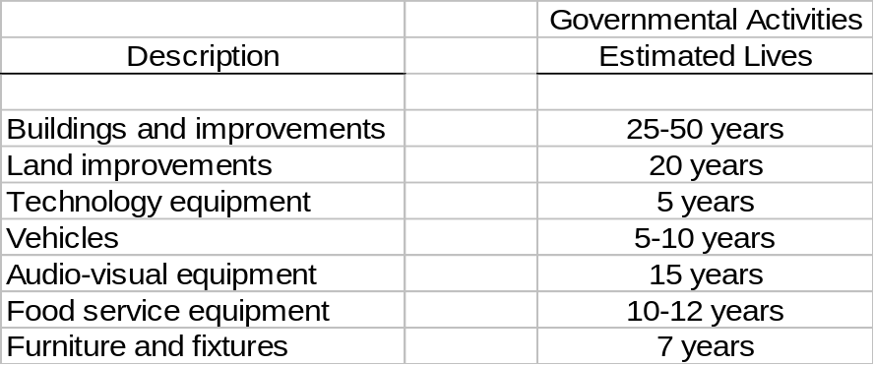
Interfund Balances

On fund financial statements, receivables and payables resulting from short-term interfund loans are classified as “interfund receivables/payables”. These amounts are eliminated in the governmental and business-type activities columns of the statements of net assets, except for the net residual amounts due between governmental and business-type activities, which are presented as internal balances.
26.
BATH COUNTY SCHOOL DISTRICT

NOTES TO BASIC FINANCIAL STATEMENTS (CONTINUED)

June 30, 2003

NOTE A – REPORTING ENTITY AND SUMMARY OF SIGNIFICANT ACCOUNTING POLICIES (continued)

Accumulated Unpaid Sick Leave Benefits

Upon retirement from the school system, an employee will receive from the District an amount equal to 30% of the value of accumulated sick leave.

Sick leave benefits are accrued as a liability using the termination payment method. An accrual for earned sick leave is made to the extent that it is probable that the benefits will result in termination payments. The liability is based on the School District’s past experience of making termination payments.

Compensated absence liabilities are recorded based on balances for classified and certified employees with twenty-seven or more years of experience at June 30, 2003.

For governmental fund financial statements the current portion of unpaid accrued sick leave is the amount expected to be paid using expendable available resources. These amounts are recorded in the account ”accumulated sick leave payable” in the general fund. The noncurrent portion of the liability is not reported. The District has set aside a board approved reserve in the amount of $30,000 for accumulated sick leave.

Budgetary Process

Budgetary Basis of Accounting: The District’s budgetary process accounts for certain transactions on a basis other than Generally Accepted Accounting Principles (GAAP). The major differences between the budgetary basis and the GAAP basis are:

Revenues are recorded when received in cash (budgetary) as opposed to when susceptible to accrual (GAAP).

Expenditures are recorded when paid in cash (budgetary) as opposed to when susceptible to accrual (GAAP).

Cash and Cash Equivalents

The District considers demand deposits, money market funds, and other investments with and original maturity of 90 days or less, to be cash equivalents.

Inventories

Supplies and materials are charged to expenditures when purchased.

27.
BATH COUNTY SCHOOL DISTRICT

NOTES TO BASIC FINANCIAL STATEMENTS (CONTINUED)

June 30, 2003

NOTE A – REPORTING ENTITY AND SUMMARY OF SIGNIFICANT ACCOUNTING POLICIES (continued)

Accrued Liabilities and Long-Term Obligations

All payables, accrued liabilities and long-term obligations are reported in the government-wide financial statements, and all payables, accrued liabilities and long-term obligations payable form proprietary funds are reported on the proprietary fund financial statements.

In general, payables and accrued liabilities that will be paid form governmental funds are reported on the governmental fund financial statements regardless of whether they will be liquidated with current resources. However, claims and judgments, the noncurrent portion of capital leases, accumulated sick leave, contractually required pension contributions and special termination benefits that will be paid from governmental funds are reported as a liability in the fund financial statements only to the extent that they will be paid with current, expendable, available financial resources. In general, payments made within sixty days after year-end are considered to have been made with current available financial resources. Bonds and other long-term obligations that will be paid from governmental funds are not recognized as a liability in the fund financial statements until due.

Fund Balance Reserves

The District reserves those portions of fund equity which are legally segregated for a specific future use or which do not represent available expendable resources and therefore are not available for appropriation or expenditure. Unreserved fund balance indicates that portion of fund equity which is available for appropriation in future periods. Fund equity reserves have been established for inventories and fixed assets.

Net Assets

Net assets represent the difference between assets and liabilities. Net assets invested in capital assets, net of related debt consists of capital assets, net of accumulated depreciation, reduced by the outstanding balances of any borrowings used for the acquisition, construction or improvement of those assets. Net assets are reported as restricted when there are limitations imposed on their use either through the enabling legislation adopted by the School District or through external restrictions imposed by creditors, grantors or laws or regulations of other governments.

Operating Revenues and Expenses

Operating revenues are those revenues that are generated directly form the primary activity of the proprietary funds. For the School District, those revenues are primarily charges for meals provided by the various schools.

28.
BATH COUNTY SCHOOL DISTRICT

NOTES TO BASIC FINANCIAL STATEMENTS (CONTINUED)

June 30, 2003

NOTE A – REPORTING ENTITY AND SUMMARY OF SIGNIFICANT ACCOUNTING POLICIES (continued)

Interfund Activity

Exchange transactions between funds are reported as revenues in the seller funds and as expenditures/expenses in the purchaser funds. Flows of cash or goods from one fund to another without a requirement for repayment are reported as interfund transfers. Interfund transfers are reported as other financing sources/uses in governmental funds and after nonoperating revenues/expenses in proprietary funds. Repayments from funds responsible for particular expenditures/expenses to the funds that initially paid for them are not presented on the financial statements.

NOTE B – CHANGES IN ACCOUNTING PRINCIPLES AND RESTATEMENT OF FUND BALANCE

For the fiscal year ended June 30, 2003, the District has implemented GASB Statement No. 34, “Basic Financial Statements – and Management’s Discussion and Analysis – for State and Local Governments”.

GASB 34 creates new basic financial statements for reporting on the School District’s financial activities. The financial statements now include government-wide financial statements prepared on an accrual basis of accounting and fund financial statements which present information for individual major funds rather than by fund type. Nonmajor funds are presented in total in one column.

The government-wide financial statements split the District’s programs between business-type and governmental activities. The beginning net asset amount for governmental programs reflects the change in fund balance for governmental funds at June 30, 2002, caused by the conversion to the accrual basis of accounting.

The School District made several changes in accounting principles during the year. For governmental activities, they began recording the current portion of the accumulated sick leave liability. These changes bring the District’s funds into compliance with the fund classifications and requirements of GASB 34.
29.
BATH COUNTY SCHOOL DISTRICT

NOTES TO BASIC FINANCIAL STATEMENTS (CONTINUED)

June 30, 2003

NOTE B – CHANGES IN ACCOUNTING PRINCIPLES AND RESTATEMENT OF FUND BALANCE (continued)

Restatement of Fund Balance – The restatement for the above changes and the transition from governmental fund balance of net assets of the governmental activities is presented below:
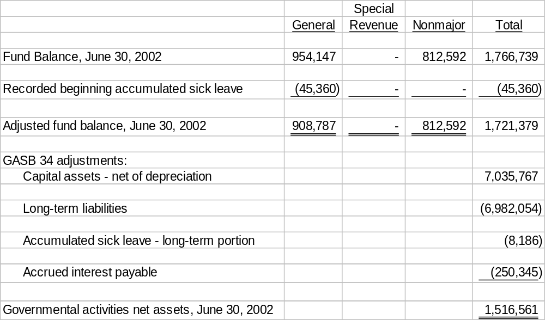

The District had a fixed asset inventory taken to comply with GASB 34. This inventory revealed the existence of proprietary fixed assets that have not previously been recorded on the books. Changes as a result of the GASB 34 implementation are as follows:

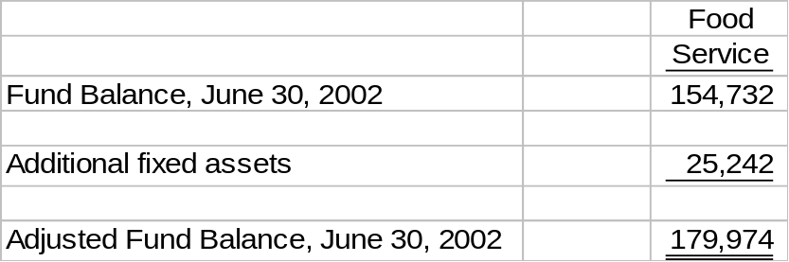
As proprietary funds are already on the accrual basis, no adjustments are necessary for the Statement of Net Assets.
30.
BATH COUNTY SCHOOL DISTRICT

NOTES TO BASIC FINANCIAL STATEMENTS (CONTINUED)

June 30, 2003

NOTE C – ESTIMATES

The preparation of financial statements in conformity with accounting principles generally accepted in the United States of America requires the District’s management to make estimates and assumptions that affect reported amounts of assets, liabilities, fund balances, and disclosure of contingent assets and liabilities at the date of the basic financial statements, and the reported amounts of revenues and expenditures during the reporting period. Actual results could differ from those estimates.

NOTE D – CASH AND CASH EQUIVALENTS

At year-end, the bank balance of the District’s cash and cash equivalents was $3,224,322. Of the total cash balance, $126,321 was covered by Federal depository insurance, the balance was covered by a collateral agreement and collateral held by the pledging banks’ trust departments in the District’s name. Cash equivalents are funds temporarily invested in securities with a maturity of 90 days or less.

Cash and cash equivalents at June 30, 2003 consisted of the following:

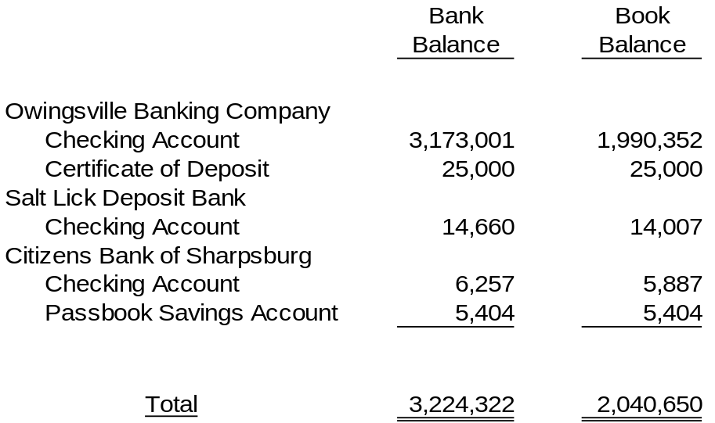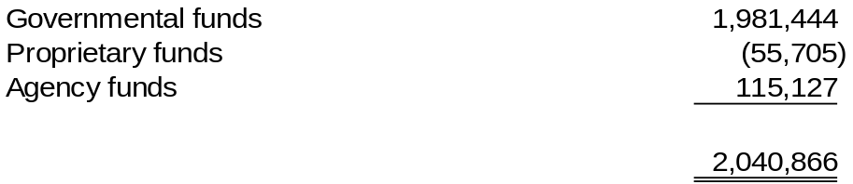Breakdown per financial statements:

31.
BATH COUNTY SCHOOL DISTRICT

NOTES TO BASIC FINANCIAL STATEMENTS (CONTINUED)

June 30, 2003

NOTE E – LEASE OBLIGATIONS AND BONDED DEBT

The original amount of each issue, the issue date and interest rates are summarized as follows:

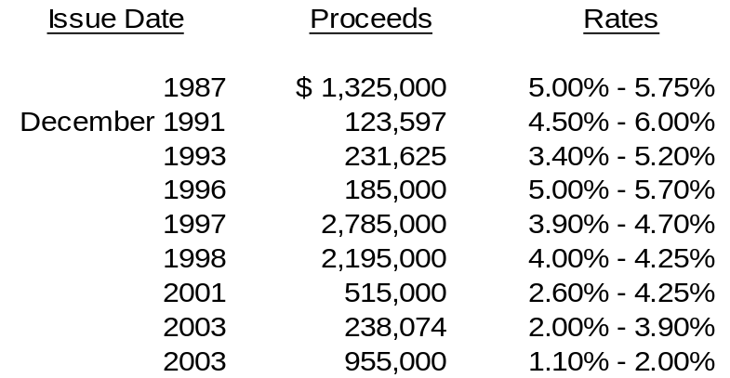
The District, through the General Fund (including utility taxes and the Support Education Excellence in Kentucky (SEEK) Capital Outlay Fund) is obligated to make payments in amounts sufficient to satisfy debt service requirements on bonds issued by the Bath County Fiscal Court and the School District Finance Corporation to construct school facilities. The District has an option to purchase the property under lease at any time by retiring the bonds then outstanding.

The proceeds from certain refunding issues have been placed in escrow accounts to be used to service the related debt.

In 1988, the District entered into “participation agreements” with the School Facility Construction Commission. The Commission was created by the Kentucky General Assembly for the purpose of assisting local school districts in meeting school construction needs. The table below sets forth the amount to be paid by the District and the Commission for each year until maturity of all bond issues.

The bonds may be called prior to maturity and redemption premiums are specified in each issue. Assuming no bonds are called prior to scheduled maturity, the minimum obligations of the District, including amounts to be paid by the Commission, at June 30, 2003, for debt service (principal and interest) are as follows:

32.
BATH COUNTY SCHOOL DISTRICT

NOTES TO BASIC FINANCIAL STATEMENTS (CONTINUED)

June 30, 2003

NOTE E – LEASE OBLIGATIONS AND BONDED DEBT (continued)

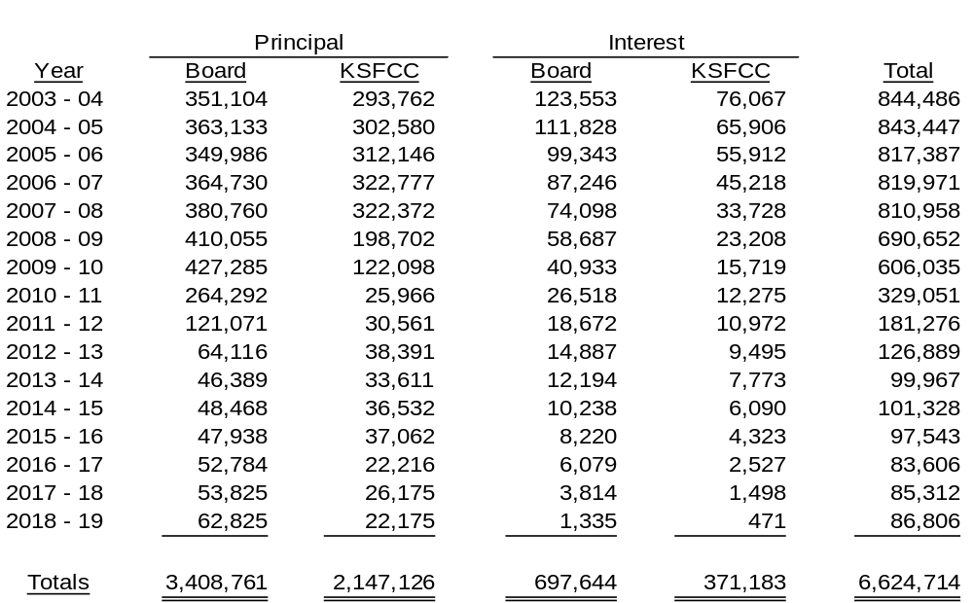
On February 27, 2003, the District issued $755,000 in school building refunding revenue bonds to defease the series of 1992 bonds. The Kentucky School Facilities Commission participated in approximately 61% of the debt service. The savings to the District was $48,252.64 for a net present value savings of 5.0345%.

The District acquired four new school buses through a KISTA Bond Issue, Series of 2003 in the par amount of $238,074. The first payment is due September 2003.

NOTE F – CAPITAL ASSETS

Capital asset activity for the fiscal year ended June 30, 2003 was as follows:

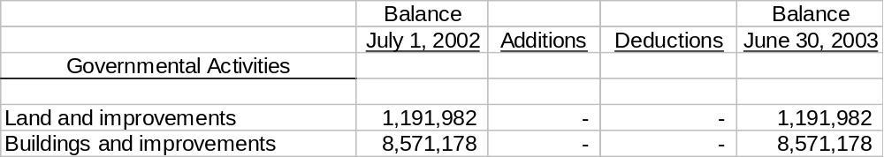

33.
BATH COUNTY SCHOOL DISTRICT

NOTES TO BASIC FINANCIAL STATEMENTS (CONTINUED)

June 30, 2003

NOTE F – CAPITAL ASSETS (continued)

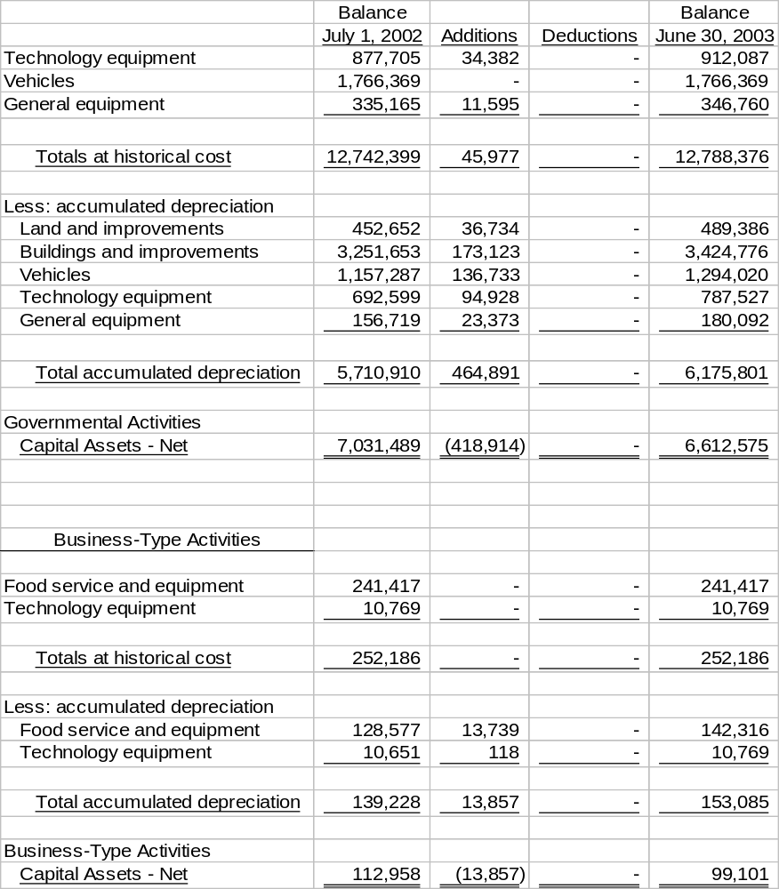
Depreciation expense was not allocated to governmental functions. It appears on the statement of activities as “unallocated”.
34.
BATH COUNTY SCHOOL DISTRICT

NOTES TO BASIC FINANCIAL STATEMENTS (CONTINUED)

June 30, 2003

NOTE G – COMMITMENTS UNDER NONCAPITALIZED LEASES

Commitments under operating lease agreements for equipment provide the minimum future rental payments as of June 30, 2003, as follows:

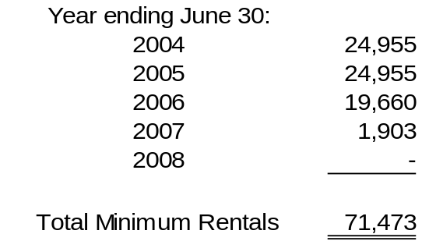
The District, as lessor, receives $700 per month from Gateway Community Services, Inc. for use of space at Owingsville Elementary School.

The District, as lessee, pays $14,000 annual rent to Mitchell Miller for 39 Cedar Creek Drive property used to house Central school.

NOTE H – RETIREMENT PLANS

Kentucky Teachers Retirement System:

Plan Description – The Bath County Public Schools contributes to the Teachers’ Retirement System of Kentucky (KTRS), a cost-sharing, multiple employer defined benefit pension plan. KTRS administers retirement and disability annuities, and death and survivor benefits to employees and beneficiaries of employees of the public school systems and other public educational agencies in Kentucky.

KTRS was created by the 1938 General Assembly and is governed by Chapter 161 Section 220 through Chapter 161 Section 990 of the Kentucky Revised Statutes (KRS). KTRS issues a publicly available financial report that includes financial statements and required supplementary information for the defined benefit pension plan. That report can be obtained by writing to Kentucky Teachers’ System, 479 Versailles Road, Frankfort, Kentucky 40601.

Funding Policy – Contribution rates are established by KRS. Members are required to contribute 9.855% of their salaries to KTRS. The Commonwealth of Kentucky is required to contribute 13.105% of salaries. The federal program for any salaries paid by that program pays the matching contributions. KTRS requires that members of KTRS occupy a position requiring either a four (4) year college degree or certification by Kentucky Department of Education (KDE).
35.
BATH COUNTY SCHOOL DISTRICT

NOTES TO BASIC FINANCIAL STATEMENTS (CONTINUED)

June 30, 2003

NOTE H – RETIREMENT PLANS (continued)

The Bath County Public School District’s total payroll for the year was $8,613,591. The payroll for employees covered under KTRS was $6,218,416.95. For the year ended June 30, 2003, the Commonwealth contributed $743,274.20 to KTRS for the benefit of our participating employees. The School District’s contributions to KTRS for the year ending June 30, 2003 were $71,649.34, which represents those employees covered by federal programs.

Substantially all other employees (classified personnel) are covered under the County Employee’s Retirement System (CERS), a cost sharing, multiple-employer, public employers retirement system. Funding for the plan is provided through payroll withholdings of 5.00% and a district contribution of 6.41% of the employee’s total compensation subject to contributions. Total payroll for employee’s covered under CERS was $2,212,362.

The contribution requirement for CERS for the year ended June 30, 2003 was $252,832 which consisted of $142,214 from the District and $110,618 from the employees. The District has no contribution requirement to KTRS.

Benefits under both plans will vary based on final compensation, years of service, and other factors as fully described in the plan documents.

The “pension benefit obligation” is a standardized disclosure measure of the present value of pension benefits which is adjusted for the effects of projected salary increases and step-rate benefits that are estimated to be payable in the future as a result of employee service to-date. The measure, which is the actuarial present value of credited projected benefits, is intended to help users assess the pensions’ funding status on a going-concern basis, assess progress made in accumulating sufficient assets to pay benefits when due and make comparisons among the plans and employers.

KTRS and CERS do not make separate measurements of assets and pension benefit obligation for individual employers. The following table presents certain information regarding the plans’ status as a whole, derived from actuarial valuations performed as of the dates indicated:
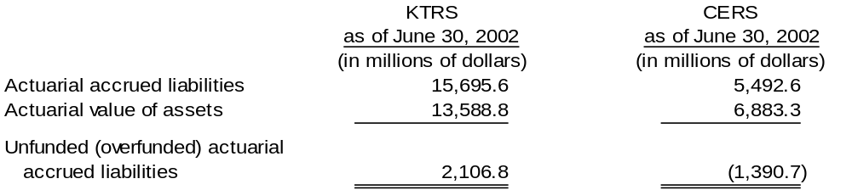
36.
BATH COUNTY SCHOOL DISTRICT

NOTES TO BASIC FINANCIAL STATEMENTS (CONTINUED)

June 30, 2003

NOTE H – RETIREMENT PLANS (continued)

Historical trend information showing KTRS’s and CERS’s progress in accumulating sufficient assets to pay benefits when due is presented in their June 30, 2002 comprehensive annual financial reports.

As the Board is only one of several employers participating in the plan, it is not practical to determine the Board’s portion of the unfunded past service cost or the vested benefits of the Board’s portion of the plan assets.

NOTE I – COMMITMENTS

Construction in progress at June 30, 2003 included Bethel School HVAC project. The project was originally awarded at $335,000.

NOTE J – CONTINGENCIES

The District receives funding from federal, state, and local government agencies and private contributions. These funds are to be used for designated purposes only. For government agency grants, if the grantor’s review indicates that the funds have not been used for the intended purpose, the grantors may request a refund of monies advanced or refuse to reimburse the District for its disbursements. The amount of such future refunds and unreimbursed disbursements, if any, is not expected to be significant. Continuation of the District’s grant programs is predicated upon the grantors’ satisfaction that the funds provided are being spent as intended and the grantors’ intent to continue their programs.

NOTE K – INSURANCE AND RELATED ACTIVITIES

The District is exposed to various forms of loss of assets associated with the risks of fire, personal liability, theft, vehicular accidents, errors and omissions, fiduciary responsibility, etc. Each of these risk areas are covered through the purchase of commercial insurance. The District has purchased certain policies which are retrospectively rated which includes worker’s compensation insurance.

NOTE L – LITIGATION

The District is subject to legal actions in various stages of litigation, the outcome of which is not determinable at this time. Management of the District and its legal counsel do not anticipate a material effect on the combined financial statements as a result of threatened, pending or ongoing litigation.
37.
BATH COUNTY SCHOOL DISTRICT

NOTES TO BASIC FINANCIAL STATEMENTS (CONTINUED)

June 30, 2003

NOTE M – RISK MANAGEMENT

The District is exposed to various risk of loss related to torts; theft of, damage to, and destruction of assets; errors and omissions; injuries to employees; and natural disasters. To obtain insurance for worker’s compensation, the District participates in the Kentucky School Board Insurance Trust Liability Fund. These public entity risk pools operate as common risk management and insurance programs for school districts and other tax supported educational agencies of Kentucky who are members of the Kentucky School Boards Association. The District pays an annual premium to each fund for coverage. Contributions to the Workers’ Compensation Fund are based on premium rates established by such fund in conjunction with the excess insurance carrier, subject to claims, experience modifications and a group discount amount. The District’s errors and omissions and general liability insurance is through Indiana Insurance Company.

The District continues to carry commercial insurance for all other risks of loss. Settled claims resulting from these risks have not exceeded commercial insurance coverage in any of the past three fiscal years.

NOTE N – DEFICIT OPERATING/FUND BALANCES

The following funds had deficit balances at June 30, 2003:

None

The following funds had expenditures in excess of revenues at June 30, 2003:

General Fund 83,167
Construction Fund 166,934
School Food Service Fund 18,810
Preschool Fund 1,062
Bath County High School Activity Fund 9,468
Bethel Elementary Activity Fund 484
Owingsville Elementary Activity Fund 1,002
Bath County Middle School Activity Fund 4,645

NOTE O – COBRA

Under COBRA, employers are mandated to notify terminated employees of available continuing insurance coverage. Failure to comply with this requirement may put the school District at risk for a substantial loss (contingency).

38.
BATH COUNTY SCHOOL DISTRICT

NOTES TO BASIC FINANCIAL STATEMENTS (CONTINUED)

June 30, 2003

NOTE P – TRANSFER OF FUNDS

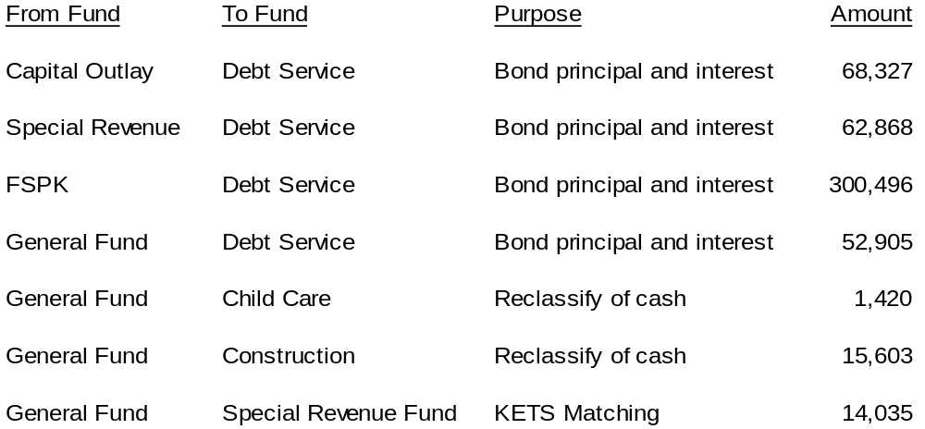The following transfers were made during the year.

NOTE Q – INTERFUND RECEIVABLES AND PAYABLES

Interfund balances at June 30, 2003 were $-0-.

NOTE R – ANNUAL FINANCIAL REPORT DIFFERENCES

The following is a reconciliation of the June 30, 2003, fund balances/retained earnings reported by the Board to the Kentucky Department of Education with that shown in the accompanying fund financial statements:

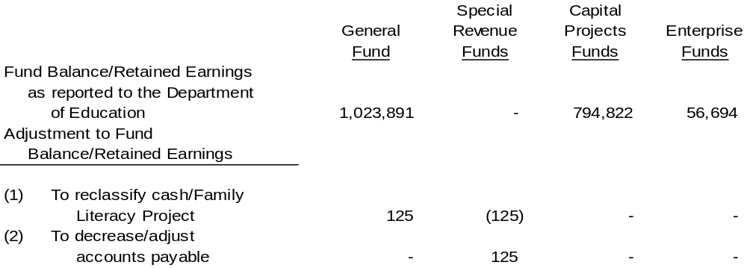
39.
BATH COUNTY SCHOOL DISTRICT

NOTES TO BASIC FINANCIAL STATEMENTS (CONTINUED)

June 30, 2003

NOTE R – ANNUAL FINANCIAL REPORT DIFFERENCES (continued)

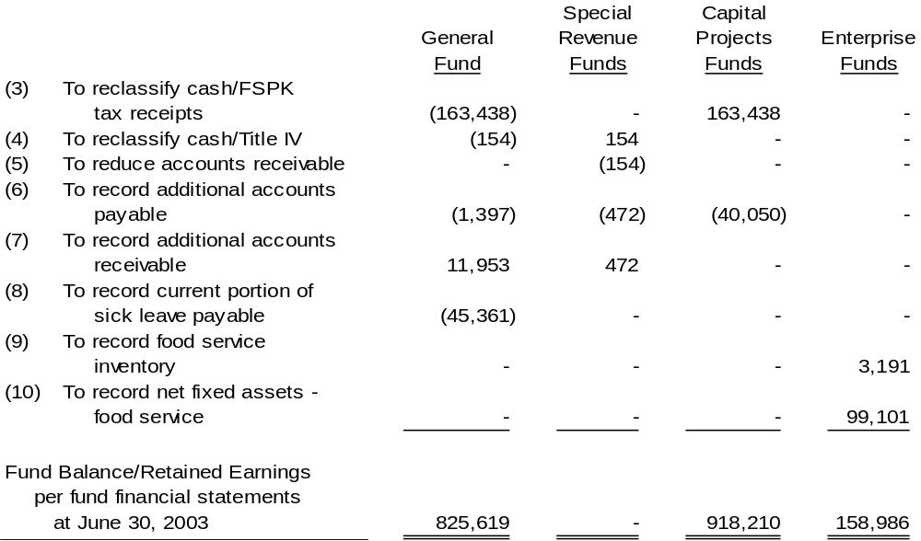

NOTE S – ON-BEHALF PAYMENTS

The following payments made by the state on behalf of employees of the District and for the benefit of the District are recognized in the government-wide financial statements as additional revenue and expenditures for the year ended June 30, 2003:

Kentucky Teacher’s Retirement System 743,274
Life Insurance 5,974
Administrative Fees 12,341
Health Insurance 783,356
Technical Education 15,855
40.

BATH COUNTY SCHOOL DISTRICT

COMBINING BALANCE SHEET – NONMAJOR GOVERNMENTAL FUNDS

At June 30, 2003

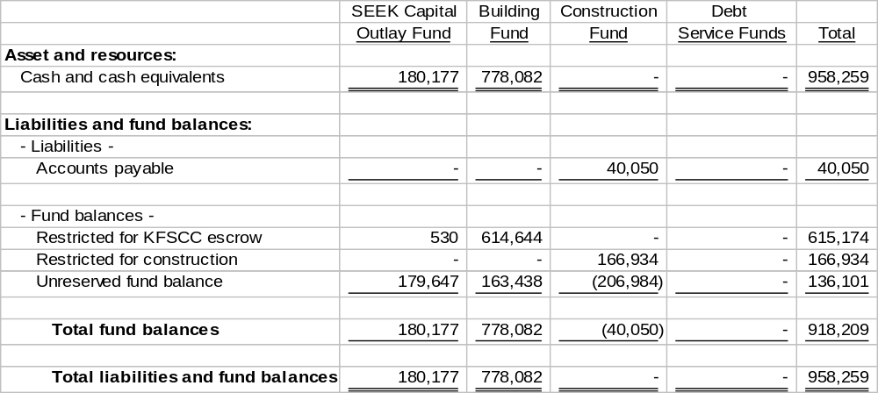
41.

BATH COUNTY SCHOOL DISTRICT

COMBINING STATEMENT OF REVENUES, EXPEDNITURES AND

CHANGES IN FUND BALANCE – NONMAJOR GOVERNMENTAL FUNDS

Year Ended June 30, 2003

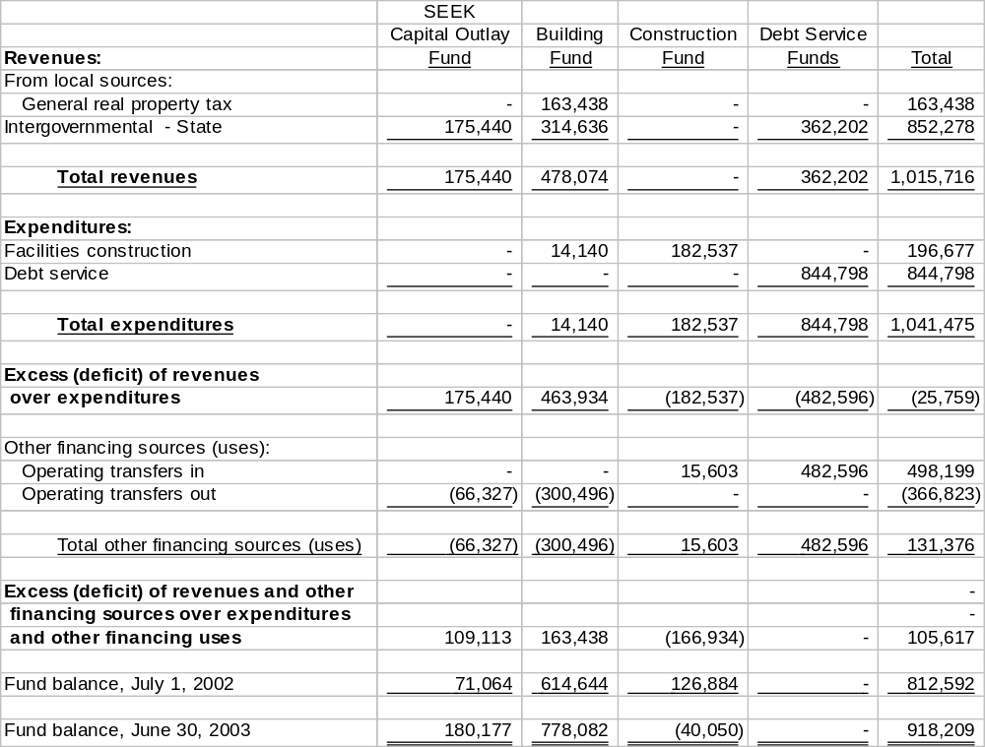

42.
BATH COUNTY SCHOOL DISTRICT

STATEMENT OF REVENUES, EXPENDITURES AND CHANGES IN FUND BALANCE

BATH COUNTY HIGH SCHOOL ACTIVITY FUND

Year Ended June 30, 2003

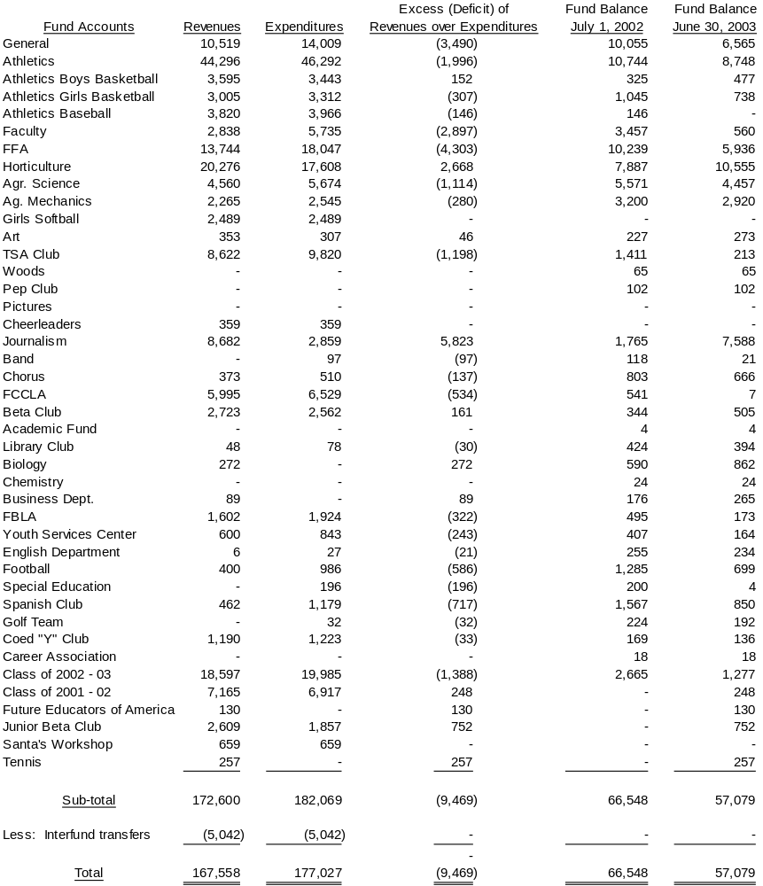
This fund maintains accounts separate from MUNIS at June 30, 2003.
43.
BATH COUNTY SCHOOL DISTRICT

COMBINING STATEMENT OF REVENUES,
EXPENDITURES, AND CHANGES IN FUND BALANCE

MIDDLE AND ELEMENTARY SCHOOL ACTIVITY FUNDS

Year Ended June 30, 2003

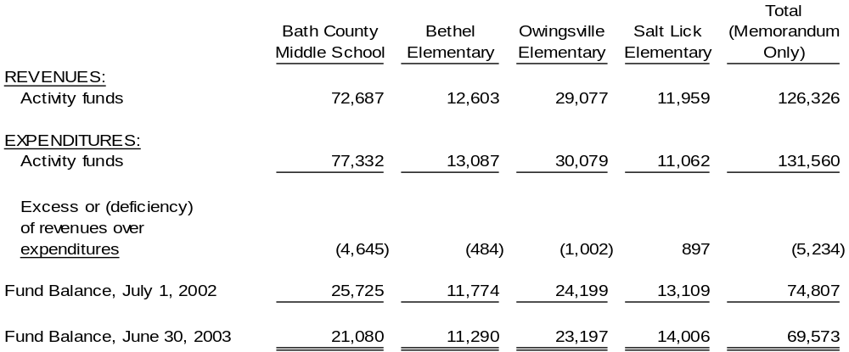

These funds maintain accounts separate from MUNIS at June 30, 2003.
44.
BATH COUNTY SCHOOL DISTRICT

SCHEDULE OF INDIVIDUAL DEBT SERVICE REQUIREMENTS

June 30, 2003

Below are minimum obligations for each individual issue:

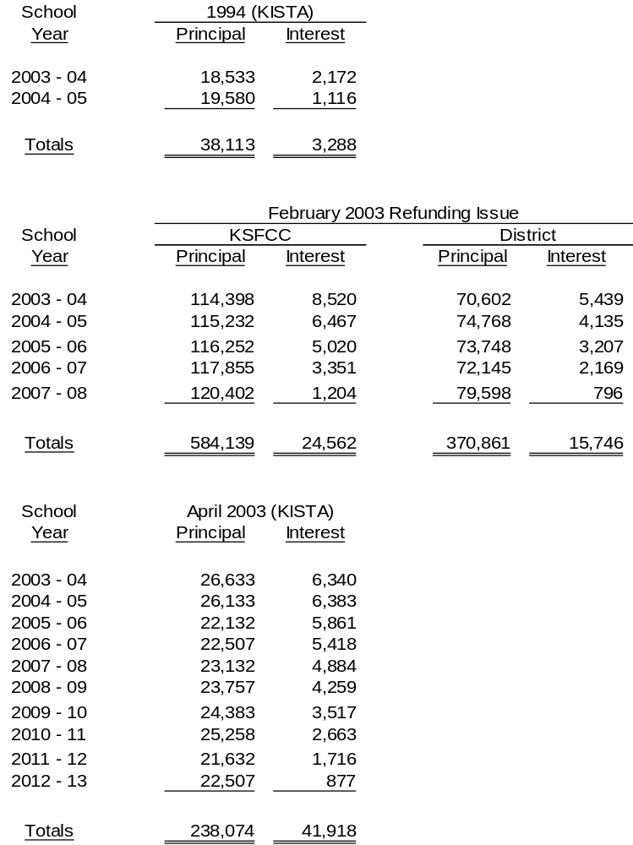
45.
BATH COUNTY SCHOOL DISTRICT

SCHEDULE OF INDIVIDUAL DEBT SERVICE REQUIREMENTS (CONTINUED)

June 30, 2003

Below are minimum obligations for each individual issue:

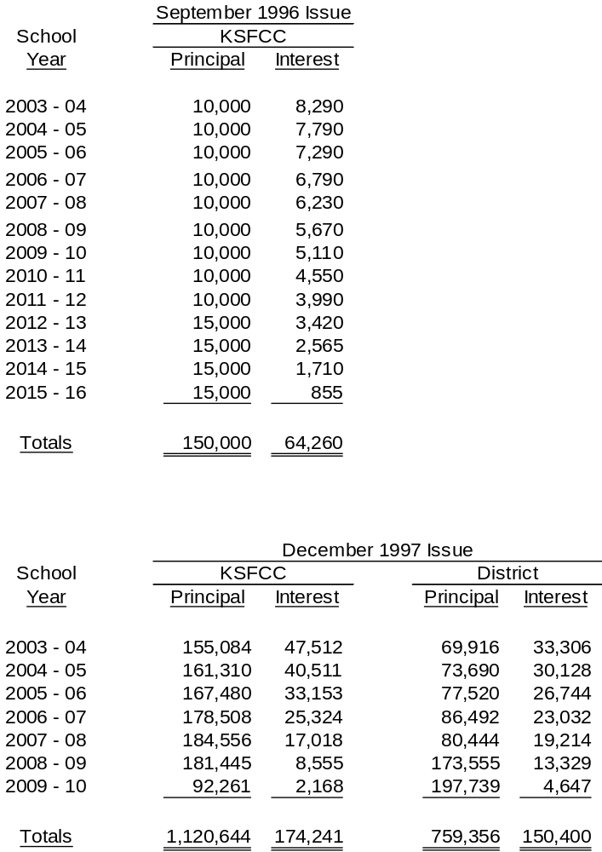

46.
BATH COUNTY SCHOOL DISTRICT

SCHEDULE OF INDIVIDUAL DEBT SERVICE REQUIREMENTS

June 30, 2003

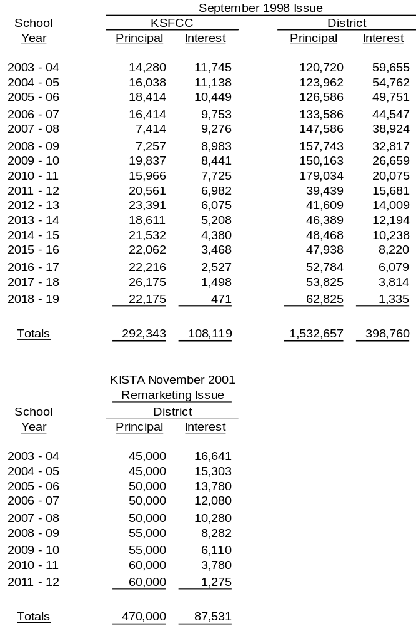Below are minimum obligations for each individual issue:

47.
BATH COUNTY SCHOOL DISTRICT

SCHEDULE OF EXPENDITURES OF FEDERAL AWARDS

Year Ended June 30, 2003

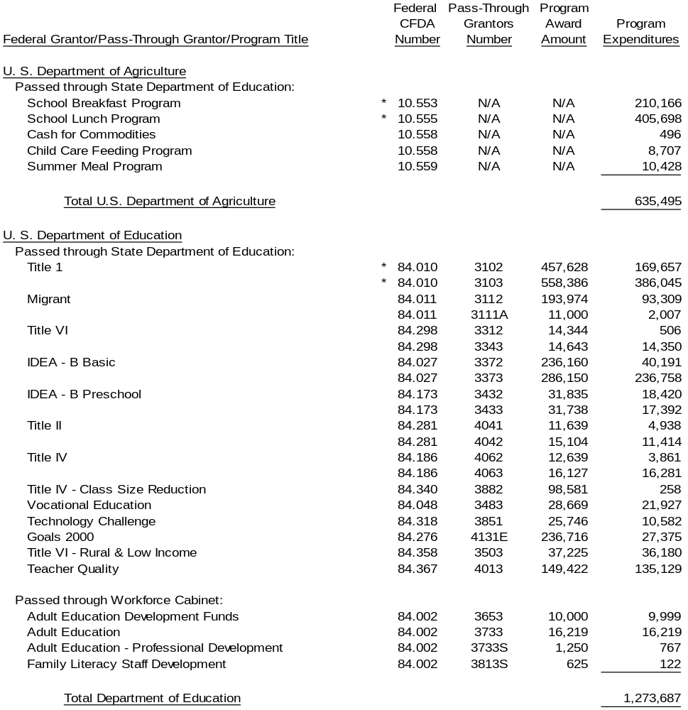

48.
BATH COUNTY SCHOOL DISTRICT

SCHEDULE OF EXPENDITURES OF FEDERAL AWARDS (continued)

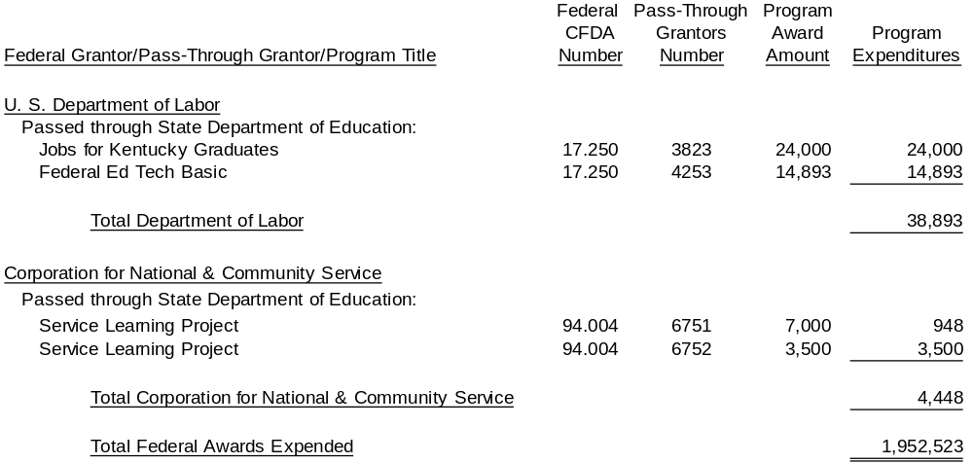Year Ended June 30, 2003

* - Indicates major programs

Note: The modified accrual basis of accounting was used in the preparation of this schedule.
49.

REPORT ON COMPLIANCE AND ON INTERNAL CONTROL OVER
FINANCIAL REPORTING BASED ON AN AUDIT OF FINANCIAL
STATEMENTS PERFORMED IN ACCORDANCE
WITH GOVERNMENT AUDITING STANDARDS

State Committee for School District Audits
Members of Bath County Board of Education
Owingsville, Kentucky

We have audited the financial statements of Bath County School District as of and for the year ended June 30, 2003, and issued our report thereon dated August 14, 2003. We conducted our audit in accordance with auditing standards generally accepted in the United States of America and the standards applicable to financial audits contained in Government Auditing Standards, issued by the Comptroller General of the United States.

Compliance

As part of obtaining reasonable assurance about whether Bath County School District’s financial statements are free of material misstatement, we performed tests of its compliance with certain provisions of laws, regulations, contracts, and grants, noncompliance with which could have a direct and material effect on the determination of financial statements amounts. However, providing an opinion on compliance with those provisions was not an objective of our audit and, accordingly, we do not express such an opinion. The results of our tests disclosed no instances of noncompliance that are required to be reported under Government Auditing Standards.

Internal Control Over Financial Reporting

In planning and performing our audit, we considered Bath County School District’s internal control over financial reporting in order to determine our auditing procedures for the purpose of expressing our opinion on the financial statements and not to provide assurance on the internal control over financial reporting. Our consideration of the internal control over financial reporting would not necessarily disclose all matters in the internal control over financial reporting that might be material weaknesses. A material weakness is a condition in which the design or operation of one or more of the internal control components does not reduce to a relatively low level the risk that misstatements in amounts that would be material in relation to the financial statements being audited may occur and not be detected within a timely period by employees in the normal course of performing their assigned functions.
50.

We noted no matters involving the internal control over financial reporting and its operation that we consider to be material weaknesses. However, we noted other matters involving the internal control over financial reporting that we have reported to management of Bath County School District in a separate letter dated August 14, 2003.

This report is intended solely for the information of management, others within the organization, board members, federal awarding agencies and pass-through entities and is not intended to be and should not be used by anyone other than those specified parties.

Chris Gooch
Certified Public Accountant

Hazard, Kentucky

August 14, 2003
51.

REPORT ON COMPLIANCE WITH REQUIREMENTS APPLICABLE
TO EACH MAJOR PROGRAM AND INTERNAL CONTROL OVER
COMPLIANCE IN ACCORDANCE WITH OMB CIRCULAR A-133

State Committee for School District Audits
Members of Bath County Board of Education
Owingsville, Kentucky

Compliance

We have audited the compliance of Bath County School District, with the types of compliance requirements described in the U.S. Office of Management and Budget (OMB) Circular A-133 Compliance Supplement that are applicable to each of its major federal programs for the year ended June 30, 2003. Bath County School District’s major federal programs are identified in the summary of auditor’s results section of the accompanying schedule of findings and questioned costs. Compliance with the requirements of laws, regulations, contracts, and grants applicable to each of its major federal programs is the responsibility of Bath County School District’s management. Our responsibility is to express an opinion on Bath County School District’s compliance based on our audit.

We conducted our audit of compliance in accordance with auditing standards generally accepted in the United States of America; the standards applicable to financial audits contained in Government Auditing Standards, issued by the Comptroller General of the United States; and OMB Circular A-133, Audits of States, Local Governments, and Non-Profit Organizations. Those standards and OMB Circular A-133 require that we plan and perform the audit to obtain reasonable assurance about whether noncompliance with the types of compliance requirements referred to above that could have a direct and material effect on a major federal program occurred. An audit includes examining, on a test basis, evidence about Bath County School District’s compliance with those requirements and performing such other procedures as we considered necessary in the circumstances. We believe that our audit provides a reasonable basis for our opinion. Our audit does not provide a legal determination on Bath County School District’s compliance with those requirements.

In our opinion, Bath County School District complied, in all material respects, with the requirements referred to above that are applicable to each of its major federal programs for the year ended June 30, 2003.

In addition, the results of our tests disclosed no instances of noncompliance of specific state statutes or regulations identified in Appendix II of the Independent Auditor’s Contract – State Audit Requirements.
52.

Internal Control Over Compliance

The management of Bath County School District is responsible for establishing and maintaining effective internal control over compliance with requirements of laws, regulations, contracts and grants applicable to federal programs. In planning and performing our audit, we considered Bath County School District’s internal control over compliance with requirements that could have a direct and material effect on a major federal program in order to determine our auditing procedures for the purpose of expressing our opinion on compliance and to test and report on internal control over compliance in accordance with OMB Circular A-133.

Our consideration of the internal control over compliance would not necessarily disclose all matters in the internal control that might be material weaknesses. A material weakness is a condition in which the design or operation of one or more of the internal control components does not reduce to a relatively low level the risk that noncompliance with applicable requirements of laws, regulations, contracts and grants that would be material in relation to a major federal program being audited may occur and not be detected within a timely period by employees in the normal course of performing their assigned functions. We noted no matters involving the internal control over compliance and its operation that we consider to be material weaknesses.

This report is intended solely for the information of and use of management, others within the organization, board members, federal awarding agencies and pass-through entities and is not intended to be and should not be used by anyone other than those specified parties.

Chris Gooch
Certified Public Accountant

Hazard, Kentucky

August 14, 2003
53.
BATH COUNTY SCHOOL DISTRICT

SUMMARY SCHEDULE OF PRIOR AUDIT FINDINGS

June 30, 2003

NONE

54.
BATH COUNTY SCHOOL DISTRICT

SCHEDULE OF FINDINGS AND QUESTIONED COSTS

June 30, 2003

- SUMMARY OF AUDIT RESULTS –

- We have issued an unqualified opinion on the financial statements.

- No reportable conditions in the internal control were disclosed by the audit of the financial statements.

- No material noncompliance was disclosed in our audit of the financial statements.

- No reportable conditions were disclosed by the audit in internal control over major programs.

- We have issued an unqualified opinion on compliance for major programs.

- The audit did not disclose any audit findings which we are required to report under Section .510(a) of A-133.

- Bath County School District had the following major programs:

U. S. Department of Education
Passes through State Department of Education
Title I

U.S. Department of Agriculture
Passes through State Department of Education
School Lunch and Breakfast Program

- The dollar threshold used to distinguish between Type A and Type B programs was $300,000.

- The auditee qualified as a low-risk auditee.

- FINDINGS RELATED TO THE FINANCIAL STATEMENTS –

None

- FINDINGS AND QUESTIONED COSTS FOR FEDERAL AWARDS –

None
55.

Bath County Board of Education
Owingsville, Kentucky

In planning and performing our audit of the financial statements of Bath County School District for the year ended June 30, 2003, we considered the District’s internal control structure to determine our auditing procedures for the purpose of expressing an opinion on the financial statements and not to provide assurance on the internal control structure.

However, during our audit we became aware of several matters that are opportunities for strengthening internal controls and operation efficiency. The memorandum that accompanies this letter summarized our comments and suggestions regarding those matters. A separate report dated August 14, 2003, contains our report on reportable conditions and material weaknesses in the District’s internal control structure. This letter does not affect our report dated August 14, 2003, on the financial statements of the Bath County Board School District.

We will review the status of these comments during our next audit engagement. We have already discussed many of these comments and suggestions with various District personnel, and we will be pleased to discuss them in further detail at your convenience, to perform any additional study of these matters, or to assist you in implementing the recommendations.

Respectfully,

Chris Gooch
Certified Public Accountant

Hazard, Kentucky

August 14, 2003

56.
BATH COUNTY SCHOOL DISTRICT

MANAGEMENT LETTER COMMENTS

Year Ended June 30, 2003

Prior Year Comments

1. Condition: A listing of mail receipts is not prepared by independent district personnel and periodically compared to munis financial information and bank deposits.

Criteria: A periodic comparison of mail receipts to munis financial information and bank deposits would strengthen controls over cash receipts.

Cause: A listing is not prepared by personnel independent of cash receipt general ledger, deposit and reconciliation function.

Effect: The likelihood of an error occurring is greater as it relates to dual controls over the cash receipts function.

Recommendation: A listing of mail receipts should be prepared by independent district personnel and periodically compared to munis financial information and bank deposits.

Management’s A person independent of the receipt function will prepare a receipt
Response: listing and periodically compare to munis financial information and bank deposits.

Current Year Management has implemented procedures for having a person
Audit Comment: independent of the receipt function prepare a receipt listing which can periodically be compared to MUNIS financial information and bank deposit information.

2. Condition: A month by month analysis of utility tax receipts by vendor is not employed by the district.

Criteria: An analysis would more readily determine if utility companies were paying currently and payments were not unusually fluctuating.

Cause: A listing by vendor is not employed by the district.

Effect: The likelihood that utility tax revenues collections are not maximized is increased without month by month analysis on a vendor basis.

Recommendation: A month by month analysis of utility tax receipts by vendor should be implemented.
57.
BATH COUNTY SCHOOL DISTRICT

MANAGEMENT LETTER COMMENTS

Year Ended June 30, 2003

Management’s Procedures will be implemented to provide a month by month
Response: analysis of utility tax receipts.

Current Year Management has not implemented procedures that enable a
Audit Comment: monthly analysis of utility tax receipts.

3. Condition: The sample of 2001-02 lunch applications examined for Bethel Elementary did not have a school official authorizing signature.

Criteria: All lunch applications should have written indication of school review.

Cause: No school official signed off on the application forms.

Effect: The review process for lunch applications is weakened.

Recommendation: District personnel should ensure that authorizing signatures are on all school lunch applications.

Management’s The District will implement procedures ensuring authorizing
Response: signatures are on all school lunch applications.

Current Year In our audit of lunch applications, we noted that authorizing
Audit Comment: signatures were on all student forms examined.

4. Condition: Bath County Middle School Activity Fund used a receipt book without preprinted numbers for the first half of the year.

Criteria: All receipts issued should be on forms with preprinted numbers.

Cause: Personnel failed to acquire a receipt book with preprinted numbers.

Effect: Cash receipts may not be complete. Receipts cannot be readily monitored on a chronological basis.

Recommendation: A receipt book should be used with preprinted numbers.

Management’s The District will implement procedures to ensure receipt books
Response: used include preprinted numbers.

Current Year In our audit of Bath County Middle School activity fund receipts we
Audit Comment: noted a prenumber receipt book in use.

58.
BATH COUNTY SCHOOL DISTRICT

MANAGEMENT LETTER COMMENTS

Year Ended June 30, 2003

Current Year Comments

Monitoring and periodic reconciliation of fixed assets

During the period audited, the District was required to inventory fixed assets, assign dollar values, estimate useful lives and accumulated depreciation and then incorporate the information compiled into its current financial reporting system. We became aware of the following during our site visits and examination of valuation reports submitted to the District:

- The District should implement written policies and procedures that address the use of an adequate form that allows for the flow of information regarding transfer of fixed assets between departments or sites.

- The District should implement written policies and procedures that allow proper notification to the purchasing coordinator for all asset transactions including purchases, transfers, disposals and sales.

- The District should ensure that fixed asset procedures include periodic site visits allowing comparison of physical assets to the financial records.

- The District should perform an assessment of personnel time allocable to maintain an accurate financial reporting fixed asset information system and determine if its current allocation for performing and monitoring fixed assets is adequate.

MANAGEMENT RESPONSE

Management will develop fixed asset policies and procedures which address the implementation of a transfer form, assurance that the purchasing coordinator has access to records for all fixed asset transactions, assessment of personnel time and development of a schedule allowing periodic comparison of physical assets to District records through site visits.

Control of purchased goods/inventory items

We noted that fundraising reports or inventory control reports were not completed for some transactions tested during our activity fund audits. They were as follows:

- Bath County High School, FCCLA fundraiser – Bumblebee Marketing

- Bath County High School – Vo-ag ferns purchased

- Bath County Middle School – pencil sales

59.
BATH COUNTY SCHOOL DISTRICT

MANAGEMENT LETTER COMMENTS

Year Ended June 30, 2003

- Bethel Elementary – ice cream sales, raffle tickets

- Salt Lick Elementary – raffle tickets

Prescribed forms should be used for all fundraising and inventory control activities to ensure adequate reconciliation of items purchased to cash collected.

MANAGEMENT RESPONSE

Management will develop procedures at the school level ensuring prescribed forms will be completed before a fundraiser is initiated. The District will monitor these procedures by periodically requesting completed forms.

Activity fund budgets

We noted no activity fund budget prepared for the 2002-03 school year for Bath County Middle School. The activity budget should be used as a monitoring tool during the year for each individual fund at the school level.

MANAGEMENT RESPONSE

Management will ensure that activity fund budgets are timely prepared by requiring a completed copy to be filed at central office for review.

