- Configuring Campus Portal
PATH: System Administration > Portal > Preferences (Tool Rights are required to access Portal preferences.)
It is not necessary to change or set a school’s Portal preferences for the Student Voice Survey. Campus Portal Messenger Inbox is always available for every school.
If you do not currently have a Campus Portal link on your district website, we recommend that you add one. The Portal web address inserts /portal/ into your district’s Infinite Campus web address. For example, if your Infinite Campus web address is https://infinitecampus.districtname.kyschools.us/campus/districtname.jsp, your portal address would be https://infinitecampus. districtname.kyschools.us/campus/portal/ districtname.jsp.
- Ensure that every student has an IC Portal account
PATH: Ad Hoc Reporting > Data Export
Run Ad Hoc Reports to make sure every student being surveyed has an Infinite Campus Portal Account. (Tool Rights are required to access.)
- To view students with accounts and the last time they logged into Portal,
run Filter: State Published > student Portal Accounts
  - If the Last Portal Login field is blank, the student has an account but has not used it.
  - If the Disabled field is yes, the student has an account but it is disabled and cannot be used.
Note: If you export to CVS format, you can open the file in Excel to further sort and filter your data.
- Create Accounts for Students as needed
If students from a participating school do not have accounts, create accounts for them.
PATH: System Administration > User Security > Student Accounts (Tool Rights are required to access.)
To make sure that all students have an account, run Add Users, which creates an account for any student who does not have an account in the selected calendar. Repeat this process for each calendar.
Students in grades 3-12 who will participate in the Student Voice Survey must know their Portal username and password. The user accounts will have the local student number as the username and the "<first name initial><last name initial><birthdate MMDDYY>" as the password. The passwords will be all lowercase.
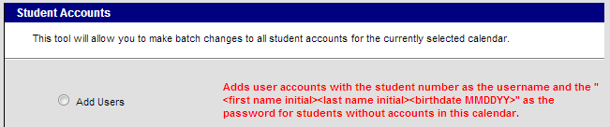
Information on additional user security options is available on Campus Community’s Knowledge Base. If you need further direction, please contact Infinite Campus Support.
- Enable Accounts for Students as needed
If student accounts are disabled, determine if these students are allowed to have Portal privileges. If they are, use PATH: System Administration > User Security > Student Accounts to use Enable Users for all disabled accounts in a calendar.
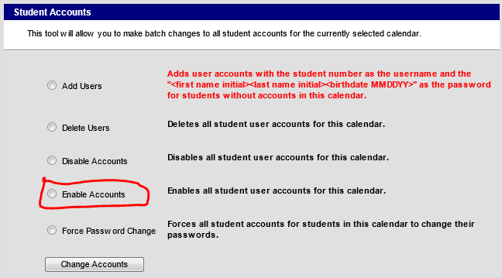
To enable individual accounts, use PATH: System Administration > User Security > Users > User Account to uncheck the Disabled checkbox.
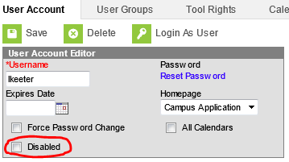
Information on additional options is available on Campus Community’s Knowledge Base. If further direction is needed to allow student access to Student Portal, please contact Infinite Campus Support.
- Test Student Accounts (By October 31)
Distribute usernames and password to grade 3-12 survey participants. Have participating students login to your Campus Portal using the links on your websites. After this test as occurred, rerun the student Portal Accounts Ad Hoc filter to identify students who were unsuccessful and may require further assistance prior to the survey administration window.
  - Campus Portal is not supported on mobile devices.
  - Mobile Portal (app) does not support the survey functionality.
  - Information on Infinite Campus supported platforms and browsers is available on Campus Community’s Knowledge Base.
- Produce a list of usernames and passwords
  - Usernames can be listed by a system administrator running the filter “student Portal Accounts” for all schools or a single school. The filter will list the school, grade, student’s first name, last name, date of birth and username. Please use extreme caution in distributing this report.
  - Passwords are encrypted in the IC database and can no longer be viewed or printed. However, depending on how your district created the student accounts, you may be able to predict the passwords. If the student accounts were created from System Administration > User Security > Student Accounts > Add Users, the user accounts will have the local student number as the username and the "<first name initial><last name initial><birthdate MMDDYY>" as the password. These passwords will be all lowercase. The ad hoc filter “student Portal Accounts” includes the student’s first name, last name, and DOB. This information can be used to formulate the password for this type of account if the password has not been changed. Please use extreme caution in distributing this report.
Additionally, teachers or guidance personnel can print class rosters with the include DOB option to obtain a listing of student names, local student numbers and DOB from which they can formulate the usernames and passwords.
  - A recent option is to enable LDAP Authentication for your IC accounts. If this option is being used, then the students would use the same username and password on the Student Portal as they use to logon to the district network.
- Establish a process for resetting passwords
If the student has forgotten their password, it will have to be reset (there is no way to retrieve a password). Your district should determine a process for how a student requests that a password be reset. Communicate this process to everyone involved in Student Voice. There is a new option that allows users to reset their own passwords but you need to research this option to determine if it is right for your district.
Information on user security is available on Campus Community’s Knowledge Base. If you need further direction, please contact Infinite Campus Support.

